Key information – Safer Internet Day 2019
For use in press releases, newsletters, websites, and more!
Safer Internet Day 2019
Safer Internet Day 2019 will be celebrated globally on Tuesday 5th February with the slogan: ‘Together for a better Internet’.
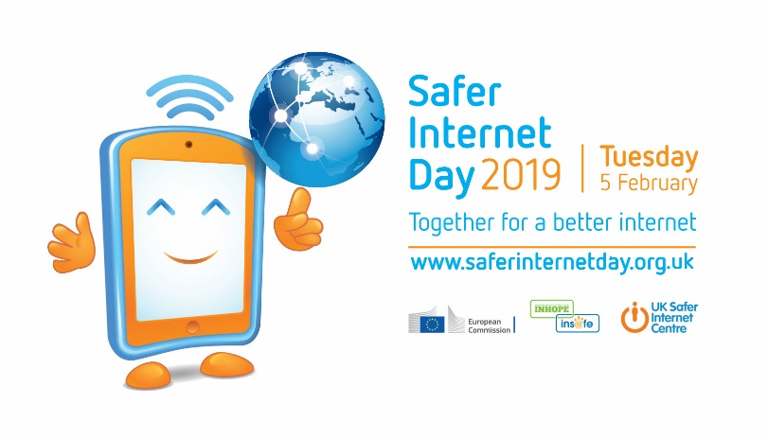
Coordinated in the UK by the UK Safer Internet Centre the celebration sees hundreds of organisations get involved and join a national conversation about using technology responsibly, respectfully, critically and creatively.
The day offers the opportunity to highlight positive uses of technology and to explore the role we all play in helping to create a better and safer online community. It calls upon young people, parents, carers, teachers, social workers, law enforcement, companies, policymakers, and wider, to join together and help to create a better internet.
Each year for Safer Internet Day the UK Safer Internet Centre creates a range of resources to help educational settings and wider to celebrate the day. This includes:
- Lessons plans, assemblies and films tailor made for all ages
- Resources to support social media involvement on Safer Internet Day
- Registration as a Safer Internet Day Supporter
- National research looking at young people’s use of technology
The UK Safer Internet Centre invites everyone to join Safer Internet Day supporters across the globe to help create a better internet on Tuesday 5th February 2019, and throughout the whole year!
UK Safer Internet Centre
The UK Safer Internet Centre is a partnership of three leading charities – Childnet International, the Internet Watch Foundation and South West Grid for Learning, (SWGfL) - with a shared mission to make the internet a better place for children and young people.
The partnership was appointed by the European Commission as the Safer Internet Centre for the UK in January 2011 and is one of the 31 Safer Internet Centres of the Insafe network.
The UK Safer Internet Centre delivers a wide range of activity to promote the safe and responsible use of technology by children and young people:
- coordinates Safer Internet Day in the UK, reaching millions every year. In 2018 Safer Internet Day reached 45 of young people and 30% of parents in the UK.
- founded and operates an online safety helpline for professionals working with children in the UK, including teachers, police officers, GPs and more
- operates the UK’s hotline for reporting online child sexual abuse imagery
- develops new advice and educational resources for children, parents and carers and teachers to meet emerging trends in the fast-changing online environment
- delivers education sessions for children, parents, carers, teachers and the wider children’s workforce, including free events across the UK
- trains children and young people to be peer educators and champions for the safe and positive use of technology
- shapes policy at school, industry and government level, both in the UK and internationally, and facilitates youth panels to give young people a voice on these issues.
For more information visit www.saferinternet.org.uk and the websites of the partners: Childnet, the Internet Watch Foundation and SWGfL.

