Child Protection Records Management Policy

Agreed by Board of Governors:

To be reviewed: As per follow up DE circulars and guidance

INTRODUCTION AND PURPOSE

The purpose of this policy is to ensure the school has record systems that support effective child protection practice. This policy is based on DE circulars 2016/20 and 2015/13 and should be read in conjunction with the school Safeguarding Policy.

As part of developing our child protection/ safeguarding arrangements, the school has developed clear guidelines for the recording, storage, retention and destruction of both manual and electronic records where they relate to child welfare concerns to ensure that the school creates and retains reliable records to demonstrate accountability for decisions and actions taken. The policy applies to all pupils registered at school or attending an Education Other Than at School (EOTAS) facility.

REQUIREMENT TO KEEP PUPIL RECORDS

The accurate recording of concerns and action taken is essential for the school to identify causes for concern at an early stage and to monitor and manage our safeguarding practices. School staff are aware of the need to record and report any child protection concerns and the appropriate procedures to be followed. A regular update is given. New staff to the school that do not start in September of a given school year are inducted in these procedures.

Belfast Model School for Girls has a responsibility to maintain our records and record keeping systems. The Board of Governors responsibility is to ensure that the arrangements operated by the school for the retention, management and release of public records comply with statutory requirements. They do this through the Safeguarding Governors’ attendance at all Safeguarding meetings. The Information Manager in the Education Authority may assist in this regard.

There is no specific legislation in respect of child protection records, however, we ensure that the principles of the requirements under the legislation and guidance listed at Annex A and B of this policy (from circular 2016/20) are adhered to.

Professional judgement will be required in assessing a concern and deciding when to commence a ‘child protection record’. All staff should follow procedures and seek immediate advice from the DT team or Principal.

A child protection record might be commenced if there is evidence of a safeguarding risk of, for example, self-harm, suicidal ideation or other behaviours that cause concern or under any of the definitions of child abuse in the school’s safeguarding policy.

RECORDING OF CHILD PROTECTION INFORMATION

It is essential that an accurate record is maintained, detailing all actions taken, in all cases of potential child abuse. There are two main ways this can be done in school.

A – Child Protection Reporting Form

Any member of staff who has a concern about the welfare or safety of a child or young person should complete a Child Protection Reporting Form (see Annex C). Any concern should be referred to the one of the Designated Teacher team as soon as practically possible, regardless of how ‘serious’ the member of staff feels the concern is.

The Child Protection Reporting Form and any further details discussed or action taken should be placed on the pupil’s Child Protection File and should be signed and dated by both parties to confirm the information is accurate.

B - UNOCINI

The ‘Understanding the Needs of Children in Northern Ireland’ (UNOCINI) is a framework to support professionals in assessment and planning to better meet the needs of children and their family.

The UNOCINI referral form will be completed whenever staff wish to refer a child or young person to children’s social services for support, safeguarding or a fuller assessment of a child’s needs. This will be done by one of the Designated Teacher Team or a Year Leader under the direction of the Vice Principal or Assistant Principal for Student Services.

Concerns that a child may be suffering, or at risk of suffering, significant harm, then an urgent referral to children’s social services through the local Gateway Service must be made and a UNOCINI submitted within 24 hours, under the direction of the Gateway Service.

Non-urgent referrals i.e. child in need/ family support referrals should be made in writing using the UNOCINI Referral form.

The consent of the parent/care giver and/or the young person (if they are competent to give this) must normally be given prior to a referral. An exception can be made when you consider that a child is in need of safeguarding and to try and gain consent may increase the risk to a child or young person. Issues of consent (including when consent is not forthcoming) must always be clearly recorded.

More detailed guidance and UNOCINI referral forms can be found at:
http://www.eani.org.uk/_resources/assets/attachment/full/0/41775.pdf

Child protection files

The Assistant Principal for Wellbeing for learning leads the Designated Teacher Team in the storage of each Note of Concern and copy UNOCINI documents in the child’s Child Protection File and supplement it with all other records created and acquired as the management of the concern progresses.

This does not involve simply leaving the form for the Assistant Principal to process. The member of the Designated Teacher Team that is dealing with or supporting a member of staff with should see this process to completion.

A Child Protection File is separate to the School Pupil/ Educational Record and is stored securely in the office document store room. Our School Pupil/ Educational Record are marked to indicate the presence of a separate confidential file using a ‘dot database system’.

The Child Protection File contains:
- Chronology of events/ action taken
- All records of concern
- Any notes initially recorded should be kept securely with the child protection file
- Records of discussions and telephone calls (with colleagues, parents and children/young people and other agencies or services)
- Correspondence with other organisations - sent and received
- Referral forms – both for support services and specialist services (irrespective of outcome)
- Formal plans linked to the child e.g. child protection plan, child in need plan
- Risk assessments
- Risk Management Plans/ Individual Safety and Support Plans
- School reports to interagency meetings and conferences
- Minutes of interagency meetings e.g. child in need, strategy, child protection conference
- Any other relevant notes/ papers

Relevant and accurate records are essential to inform effective decision making and assist in the sharing of appropriate information. They should contain factual information or be clearly specified as unsubstantiated and should include all relevant information even if it appears contradictory.

Any significant event or change which has an impact on the child’s welfare must be included in the Child Protection File, and noted on the chronology of events/ action taken, even if it seems to be contradictory. As a guideline, although not exhaustive, the following may be relevant:

- Change of circumstances: changes of carer, address, legal status, school, family circumstances and household composition.
- Issues for the child: physical or mental health issues, incidents of abuse, losses, developmental issues, incidents of running away/going missing, incidents re bullying, offending or police involvement.
- Family issues: changes in family composition, loss and separation, domestic violence, financial or housing problems, physical or mental health, substance misuse, homelessness, imprisonment, victimisation.
- Professional involvement: referrals made, involvement of other agencies, assessments, significant decisions, interventions, social services involvement.

Any decisions made must be recorded together with reasons for the agreed action, this will be vital to any future processes, such as retrospective or historical allegations and Case Management Reviews. It is vitally important to record all relevant details, regardless of whether or not the concerns are shared with either the police or social services.

When Social Services inform the school that a child’s name has been placed on the Trusts’ Child Protection Register (CPR), the school must maintain a record of this fact and associated documentation from Social Services on the child’s Child Protection file.

Complaints Against School Staff

Where a complaint is made about possible abuse by a member of staff of the school, the procedures set out in DE Circular 2015/13 are followed.

As set out in Circular 2015/13, all allegations of a child abuse nature are recorded in the Record of Child Abuse Complaints book which is retained securely in a locked area of the Principal’s desk.

A record of this information is placed on the relevant pupil’s Child Protection File.

These records are signed and dated by the Principal. If the Principal is the subject of the concern, the allegation is reported immediately to the Chair of the Board of Governors, Deputy Chairperson, Designated Governor for Child Protection and the person appointed to be the Lead Individual, and the record retained in the school, on both the child’s Child Protection File and the file of the member of staff concerned.

If, on foot of a subsequent investigation by one of the investigating agencies, the member of staff concerned is totally exonerated:
- the record on the staff member’s file must be expunged
- the entry in the Record of Child Abuse Complaints struck through with an explanation entered
- the record on the child’s file should be noted with the outcome of the investigation, and should stand until the child’s D.O.B +30 years.

Given the number of recent historical allegations, unless the member of staff concerned is totally exonerated, the record should be retained indefinitely. If a closure or an amalgamation of an educational establishment(s) occurs or when a member of staff retires, leaves or changes post, advice should be sought from the relevant Employing Authority and/or the Information Commissioner’s Office.

STORAGE OF CHILD PROTECTION INFORMATION

Child Protection information is confidential and should not be kept on the child’s Pupil/ Educational Record. We have a separate secure confidential filing system for Child Protection concerns, located in a locked cabinet in the Main Office store.

The filing cabinet is only accessible to the Designated Teacher, Deputy Designated Teacher or Principal. The cabinet is not accessible to anyone else, including administrative staff, the ETI and members of the Board of Governors. The keys to the cabinet should not be removed from the premises and are stored securely in the safe. The ETI will seek assurance that child protection records are held securely and in a confidential manner.

Child Protection Records must not be removed from the school premises, except when taken to a case planning meeting in respect of the child, or on foot of a court order. If information needs to be taken out of the school, it must be transported securely and a record should be kept of when it was removed, by whom, for what purpose, and when it was returned. Permission for this can only be granted by the principal, or the Vice Principal in the Principal’s absence.

Storing Information Electronically

There are inherent dangers in keeping sensitive information electronically and extra care must be taken. Such information should never be held on computers to which staff or pupils could have free access, including SIMS.net. If information is held electronically, whether on a laptop or on a portable memory device, all must be encrypted and appropriately password protected.

Records can be stored electronically on the C2k system and Private 10 has been allocate exclusively to Child Protection with access limited to the Principal, Designated Teacher and Deputy Designated Teacher.

ACCESS TO RECORDS AND SHARING OF INFORMATION

The Data Protection Act 1998 and GDPR March 2017 establishes a framework of rights and duties which are designed to safeguard personal data. This framework balances the legitimate needs of organisations to collect and use personal data for business and other purposes against the right of individuals to respect for the privacy of their personal details.

When considering what information can be shared, including on transfer to another school, all schools must ensure that they comply with the 8 principles in the Data Protection Act 1998 :
- Personal data shall be processed fairly and lawfully and, in particular, shall not be processed unless –
(a) at least one of the conditions in Schedule 2 is met, and
(b) in the case of sensitive personal data, at least one of the conditions in Schedule 3 is also met.
- Personal data shall be obtained only for one or more specified and lawful purposes, and shall not be further processed in any manner incompatible with that purpose or those purposes.
- Personal data shall be adequate, relevant and not excessive in relation to the purpose or purposes for which they are processed.
- Personal data shall be accurate and, where necessary, kept up to date.
- Personal data processed for any purpose or purposes shall not be kept for longer than is necessary for that purpose or those purposes.
- Personal data shall be processed in accordance with the rights of data subjects under this Act.
- Appropriate technical and organisational measures shall be taken against unauthorised or unlawful processing of personal data and against accidental loss or destruction of, or damage to, personal data.
- Personal data shall not be transferred to a country or territory outside the European Economic Area unless that country or territory ensures an adequate level of protection for the rights and freedoms of data subjects in relation to the processing of personal data.

In all cases the information should be adequate, relevant and not excessive.

In relation to the first data protection principle which requires that personal information is used fairly, lawfully and can satisfy relevant conditions for processing, this will require each school to ensure that:

- fair processing information is provided to parents, children and staff explaining what information is held by the school and when information might be transferred to a new school (this might be contained within the school’s child protection policy)
- the transfer of information is lawful (i.e. that it does not breach confidentiality, or the Human Rights Act)
- a condition for processing can be satisfied from Schedule 2 in the case of personal data, and a further condition from Schedule 3 if sensitive personal data (which given the nature of information within child protection records will invariably be sensitive).

Actions and outcomes, including the basis for sharing and how the information meets the requirements under the Data Protection Act (DPA) must be clearly recorded and it should be made clear what is factual and up to date and what is unsubstantiated information. Third party information, which is not linked in any way to the child whose record is being transferred, should be redacted.

The Information Commissioner’s Office (ICO) has published a statutory Data Sharing Code of Practice to assist organisations to comply with the DPA. The code is applicable to all organisations involved in sharing personal data, whether this is within different branches of the same organisation, or with another third party organisation.

In accordance with the Data Protection Act 1998, the school is the Data Controller and has responsibility to ensure that the Act is complied with.

Child Protection records may be exempt from the disclosure provisions of the Data Protection Act 1998 in cases where disclosure may cause serious physical or emotional harm to the child or any other person. This means that neither pupils nor their parents have an automatic right to access them. However, the exemption only applies to the information that may cause harm and is not a blanket exemption for the file as a whole. In addition, the exemption can only be relied upon if it is endorsed by the opinion of an appropriate health professional. (Data Protection (Subject Access Modification) (Health Order) 2000).

The exemption should be applied on a case-by-case basis, applying in each case the test of prejudice. Where the Principal receives a request for subject access from a pupil or his/her parent, or from a member of staff against whom an allegation has been made, and is in doubt whether the data should be disclosed, the person responsible for information management in the Education Authority Region should be consulted. More guidance on the exemptions in the Data Protection Act can be found on the ICO website at:

https://ico.org.uk/for-organisations/guide-to-data-protection/exemptions/

In particular, Section 29 of the Data Protection Act specifies that subject access need not be given in any case where to do so would be to prejudice the prevention and detection of crime, or the prosecution or apprehension of offenders. The Information Commissioners Office has developed comprehensive guidance on how this exemption operates:

https://ico.org.uk/media/for-organisations/documents/1594/section-29.pdf

Sharing Information within the School

Child Protection information is confidential and often highly sensitive and decisions to share, or not to share, must always be made in the interest of protecting the child if at risk of significant harm. There is also a duty to protect individuals and, as such, within a school information should only be shared with staff who require access to it, in order to work in a safe and informed way with the child and family. The DT should record who information is shared with, when, and the reasons for this. All staff should understand the importance of maintaining confidentiality and the consequences of any breach.

Staff must always consider the safety and welfare of the child when making decisions about whether to share confidential information. Subject to the provisions of the Data Protection Act 1998 the disclosure of confidential information is allowed when necessary to protect or safeguard a child.

Any information relating to a third party (another child or adult) should not normally be made available to anyone, unless the third party gives explicit consent to the disclosure being made. Records demanded by a court must be redacted to protect the identity of a third party. For this reason, and in the general interests of confidentiality, concerns about pupils should be recorded on an individual basis, rather than in a diary, or log, where several children’s and staff names may appear on one page.

Sharing Information with Others

The subject of the record, those with parental responsibility, or the pupil’s guardian ad litem, i.e. an independent officer of the Court appointed under the Children (NI) Order 1995 to safeguard the interest of children who are the subject of Court proceedings, do have the right in law to request access to the records at any stage, subject to the exemptions under the Data Protection Act 1998.

Access to child protection records should be strictly on a need-to-know basis, and a record should be kept to identify who has requested access, when and for what purpose. We will follow guidance issued by the Information Commissioner’s Office (ICO) “Dealing with subject access request involving other people’s information” https://ico.org.uk/for-organisations/guide-to-data-protection/principle-6-rights/subject-access-request/. Advice can also be sought from the Information Manager in the relevant Education Authority Region.

Information must always be shared with other agencies where there is a legal duty to do so e.g. PSNI and Social Services. It should, however, be noted that the PSNI have no automatic right to access data and must complete Form 81, stating the data they require and the specific case to which it relates. Form 81 requests should always be discussed with the Principal.

Consent to share information should be sought where possible, however, sharing, even without consent, will normally be justified, if there is evidence of reasonable cause to believe that a child is suffering, or is at risk of suffering harm. Ensure that the information shared is necessary for the purpose for which it is being shared, is shared only with those people who need to have it, is accurate and up-to-date, and is shared securely.

More guidance on information sharing can be found in Section 8 of Co-operating to Safeguard Children and Young People in Northern Ireland (March 2016) at https://www.health-ni.gov.uk/publications/co-operating-safeguard-children-and-young-people-northern-ireland and on the Information Commissioners website at https://ico.org.uk/for-organisations/guide-to-data-protection/

Reporting to Board of Governors
Child Protection is a standing agenda item for Board of Governor meetings and that the Designated Teacher prepares a termly report for the meeting of all child protection activities and a full annual report for the Board of Governors on all Child Protection matters. The annual report should include information such as what child protection training has been provided for staff/volunteers, statistics in relation to child protection concerns e.g. the number of referrals to Social Services and number of children on the child protection register, the number of complaints against staff, any safeguarding/child protection initiatives delivered as part of the school’s preventative curriculum, policy reviews undertaken. All reports must be anonymised in keeping with the principle of confidentiality.
The school’s Record of Child Abuse Complaints should be made available to the Board of Governors at least annually. If an allegation is recorded anonymised information will be shared with Governors including what action was taken and the outcome of the complaint. The Chair should sign and date the Record of Child Abuse Complaints annually, even if there have been no entries. The Education Training Inspectorate will ask to see the Record and Chair’s signature during inspections, but not the content or detail of complaints.
Education Training Inspectorate (ETI)
The ETI are not entitled to see the content of any child protection record, however, they do need to be assured that records exist and are held in a secure and confidential manner. They will also request sight of the Record of Child Abuse Complaints and, while they are not entitled to view the content, they will check that the book is completed and signed off annually by the Chair of the Board of Governors.

TRANSFER OF CHILD PROTECTION RECORDS

Transfer of Records

Under the Education (Pupil Records and Reporting) (Transitional) Regulations (NI) 2007, Boards of Governors are required to make arrangements to transfer a formal record of a pupil’s academic achievements, other skills and abilities and progress within 15 school days of a pupil transferring schools. The requirement does not include the transfer of child protection records. However, where there have been, or are current, concerns about a pupil the school should consider what information should be shared with the new school.

Past safeguarding concerns and the response to these can be significant, should concerns arise for the child at a later time. The third data protection principle is key in relation to deciding whether to transfer past concerns. If the information, current or historical, is deemed to be relevant then it should be shared.

The Designated Teacher is responsible for ensuring that copies of relevant child protection records are transferred to the DT of the receiving school in the most secure and appropriate manner to minimise the risk of any data breach. The data controller, i.e. the school, is accountable for any data breach. Hand delivery or collection of documents is preferable but where documents are to be posted these must be double-enveloped, marked on the inner envelope as ‘sensitive personal data’ and sent by registered post.

When a child on whom the school holds safeguarding or child protection information leaves the school and the school are unaware of the new school they must notify the Education Welfare Service at the Education Authority who will then attempt to locate the child. Social Services must be informed immediately if the child has a Child Protection Plan or is a Looked After Child. The school must retain the child’s child protection records and forward the relevant information to the receiving school when the child has been traced.

When a child whose name is on the Child Protection Register changes school, the school which the child is leaving should inform the receiving school immediately that his/her name is on the Register and pass on contact details for the social worker. The school should then destroy all child protection records on the child supplied by Social Services, including records of case conferences, and should inform the child’s Case coordinator in Social Services. The remaining child protection record should be copied, as relevant, to the new school. When considering what information is relevant advice can be sought from the CPSSS. The school to which the child is transferring should contact the child’s social worker for relevant information. The leaving school can retain original copies of their own documents.

It is good practice for the DT to discuss concerns directly with the DT from the receiving school in advance of sending the child protection record.

CLOSURE, RETENTION AND DISPOSAL OF CHILD PROTECTION RECORDS

Closure

When a pupil leaves the school or child protection concerns cease to be current or ongoing, and records cease to be of active use other than for reference purposes, the child’s individual Child Protection File should be closed. The DT should consult the School’s Disposal of Records Schedule, review the file and mark the front cover of the file indicating the date on which the file can be destroyed, for example, 30 years from the pupil’s date of birth. Closing a file simply means that no further papers can be added. If new concerns arise a new file can be opened and cross-referenced with the previous record.

Retention of Child Protection Records

In order to determine how long child protection records should be kept there are a number of guiding principles. The Data Protection Act 1998 requires that personal information should be:

- Adequate, relevant and not excessive for the purpose(s) for which they are held (third principle)
- Accurate and where necessary kept up to date (fourth principle)
- Not kept for longer than is necessary for its purpose(s) (fifth principle)

The school is the Data Controller and the school has responsibility to ensure that the Act is complied with.

The school has a Record Retention and Destruction Policy and a Disposal of Records Schedule.

The potential for historical allegations to be made should also be considered in determining retention periods for child protection records.

Retention Periods for Child Protection Records

It is recommended that, in general, child protection records should be retained by the school for the following periods:

Record | Retention Period
Pupil Child Protection Case Files | DOB + 30 years
The school’s confidential Record of Child Abuse Complaints | Indefinitely*
If Social Services inform the school that a child’s name has been placed on the Child Protection Register | Maintain a record of this fact and associated documentation from Social Services on the child’s file while he/she continues to attend. On transfer, the school should inform the new school and destroy all social services records. The record on the Child Protection File will remain until D.O.B + 30 years.
If Social Services inform the school that a child’s name is removed from the Child Protection Register | On transfer to a new school, the school should destroy any child protection records on the child supplied by Social Services, including records of case conferences.  The record on the Child Protection File will remain until D.O.B + 30 years.
Complaint against a member of staff  Staff members file  Child’s Child Protection File  Record of Child Abuse Complaints | Indefinitely* unless totally exonerated (see para. 3.16)  D.O.B + 30 years  Indefinitely*
Complaint to be pursued under the school’s disciplinary procedures
Staff members file  Child’s Child Protection File  Record of Child Abuse Complaints | 5 years  D.O.B + 30 years  Indefinitely*

* as a general guide ‘indefinitely’ should be a minimum of 40 years.

Disposal
At the end of the agreed retention period records should be securely disposed of, for example, incinerated or shredded in the presence of a member of the school or entrusted to a firm specialising in the destruction of confidential material. Information held electronically within private folders on the C2k system should also be deleted within the timescales set. Following deletion, the electronic records will be held securely on the centralised backup for a period of time but in due course will be overwritten and the documents removed. No evidence will remain on the C2k system.
The National Archives has issued guidance based on the Independent Inquiry into Child Sexual Abuse stressing that any information which may be required by the Inquiry should not be destroyed. This principle should be applied in all cases and careful review before destruction of documents.
https://www.csa-inquiry.independent.gov.uk/news/chair-of-the-inquiry-issues-guidance-on-destruction-of-documents

SCHOOL CLOSURES AND AMALGAMATIONS

Where a school is closing and the site is being sold or reassigned for other use then the Employing Authority should take responsibility for the records from the date of the school closure. In such cases the school should contact the Information Manager in the Employing Authority regarding secure transfer of the records. Hand delivery or collection of documents is preferable but where documents are to be posted these must be double-enveloped, marked on the inner envelope as ‘sensitive personal data’ and sent by registered post.

When a school is preparing to close, the Designated Teacher should identify pupils with a child protection record. Every effort must be made to establish the pupil’s new school and the processes in Section 7 followed. After the transfer of relevant information has taken place, the child’s file should be forwarded to the Employing Authority for retention until the child reaches the age of D.O.B + 30 years. Child protection records of pupils who have already left the school which are still within the retention period should also be transferred, securely as above, to the Employing Authority for retention and destruction at the appropriate time.

If a number of schools have merged onto one site and then function as one school, it is sensible to retain all records relating to the schools on the one site. These records should be kept in the confidential locked filing cabinet, accessible only by the Designated Teacher and the Principal.

ANNEX A

LEGISLATIVE CONTEXT

The formation of this policy has been guided by circular 216/20 which in turn was informed by the United Nations Convention on the Rights of the Child and takes account of the principles and requirements of the following legislation and guidance:

Primary Legislation

- Public Records Act (NI) 1923
- Disposal of Documents (NI) Order 167, 1925
- The Limitation (Northern Ireland) Order 1989
- Children (NI) Order 1995
- Data Protection Act 1998
- Human Rights Act 1998
- Freedom of Information Act 2000
- Education and Libraries (NI) Order 1986
- Education and Libraries (NI) Order 2003
- The Education (NI) Order 2006

Subordinate Legislation

The Education (Pupil Records and Reporting) (Transitional) Regulations (NI) 2007
http://www.legislation.gov.uk/nisr/2007/43/contents/made

The Education (Pupil Reporting) Regulations (Northern Ireland) 2009
http://www.legislation.gov.uk/nisr/2009/231/pdfs/nisr_20090231_en.pdf

The Data Protection (Subject Access Modification) (Health Order) 2000
http://www.legislation.gov.uk/uksi/2000/413/contents/made

ANNEX B

GUIDANCE

- Co-operating to Safeguard Children and Young People in Northern Ireland (March 2016) at https://www.health-ni.gov.uk/publications/co-operating-safeguard-children-and-young-people-northern-ireland

- DE: Model Schools Disposal of Documents Schedule https://www.education-ni.gov.uk/articles/disposal-school-records

- Accessing Pupils’ Information (Information Commissioners Office)
https://ico.org.uk/for-the-public/schools/pupils-info/

- UNOCINI –Understanding the Needs of Children in Northern Ireland (UNOCINI) framework

- CPSSS School Governors Handbook (2015)
(issued by Child Protection Support Service for Schools)
https://www.education-ni.gov.uk/publications/cpsss-board-governors-handbook

- DE Circular 1999/10: Pastoral Care in Schools: Child Protection
https://www.education-ni.gov.uk/publications/pastoral-care-schools-child-protection

- DE Circular 2003/13: Welfare and Protection of Pupils
https://www.education-ni.gov.uk/publications/circular-200313-welfare-and-protection-pupils-education-and-libraries-ni-order-2003

- DE Circular 2015/13: Dealing with allegations of abuse against a member of staff
https://www.education-ni.gov.uk/publications/circular-201513-dealing-allegations-abuse-against-member-staff

- Education Authority website: http://www.eani.org.uk/#

- ACPC (Area Child Protection Committee) policies and procedures and other information is available on the SBNI website at:
http://www.safeguardingni.org/resources

General Records Management Guidance:
Lord Chancellor’s Code of Practice on Management of Records (Section 46 FOI Act)
http://www.proni.gov.uk/lord_chancellor_s_code_of_practice_-_section_46.pdf

Information Commissioners Office - Data Protection – The Eight Principals
https://ico.org.uk/for-organisations/guide-to-data-protection/

Information Commissioners Office – FOIA - Section 46 Code of Practice – records management
https://ico.org.uk/media/for-organisations/documents/1624142/section-46-code-of-practice-records-management-foia-and-eir.pdf

Information Commissioners Office – Subject Access Code of Practice
https://ico.org.uk/media/for-organisations/documents/1065/subject-access-code-of-practice.pdf

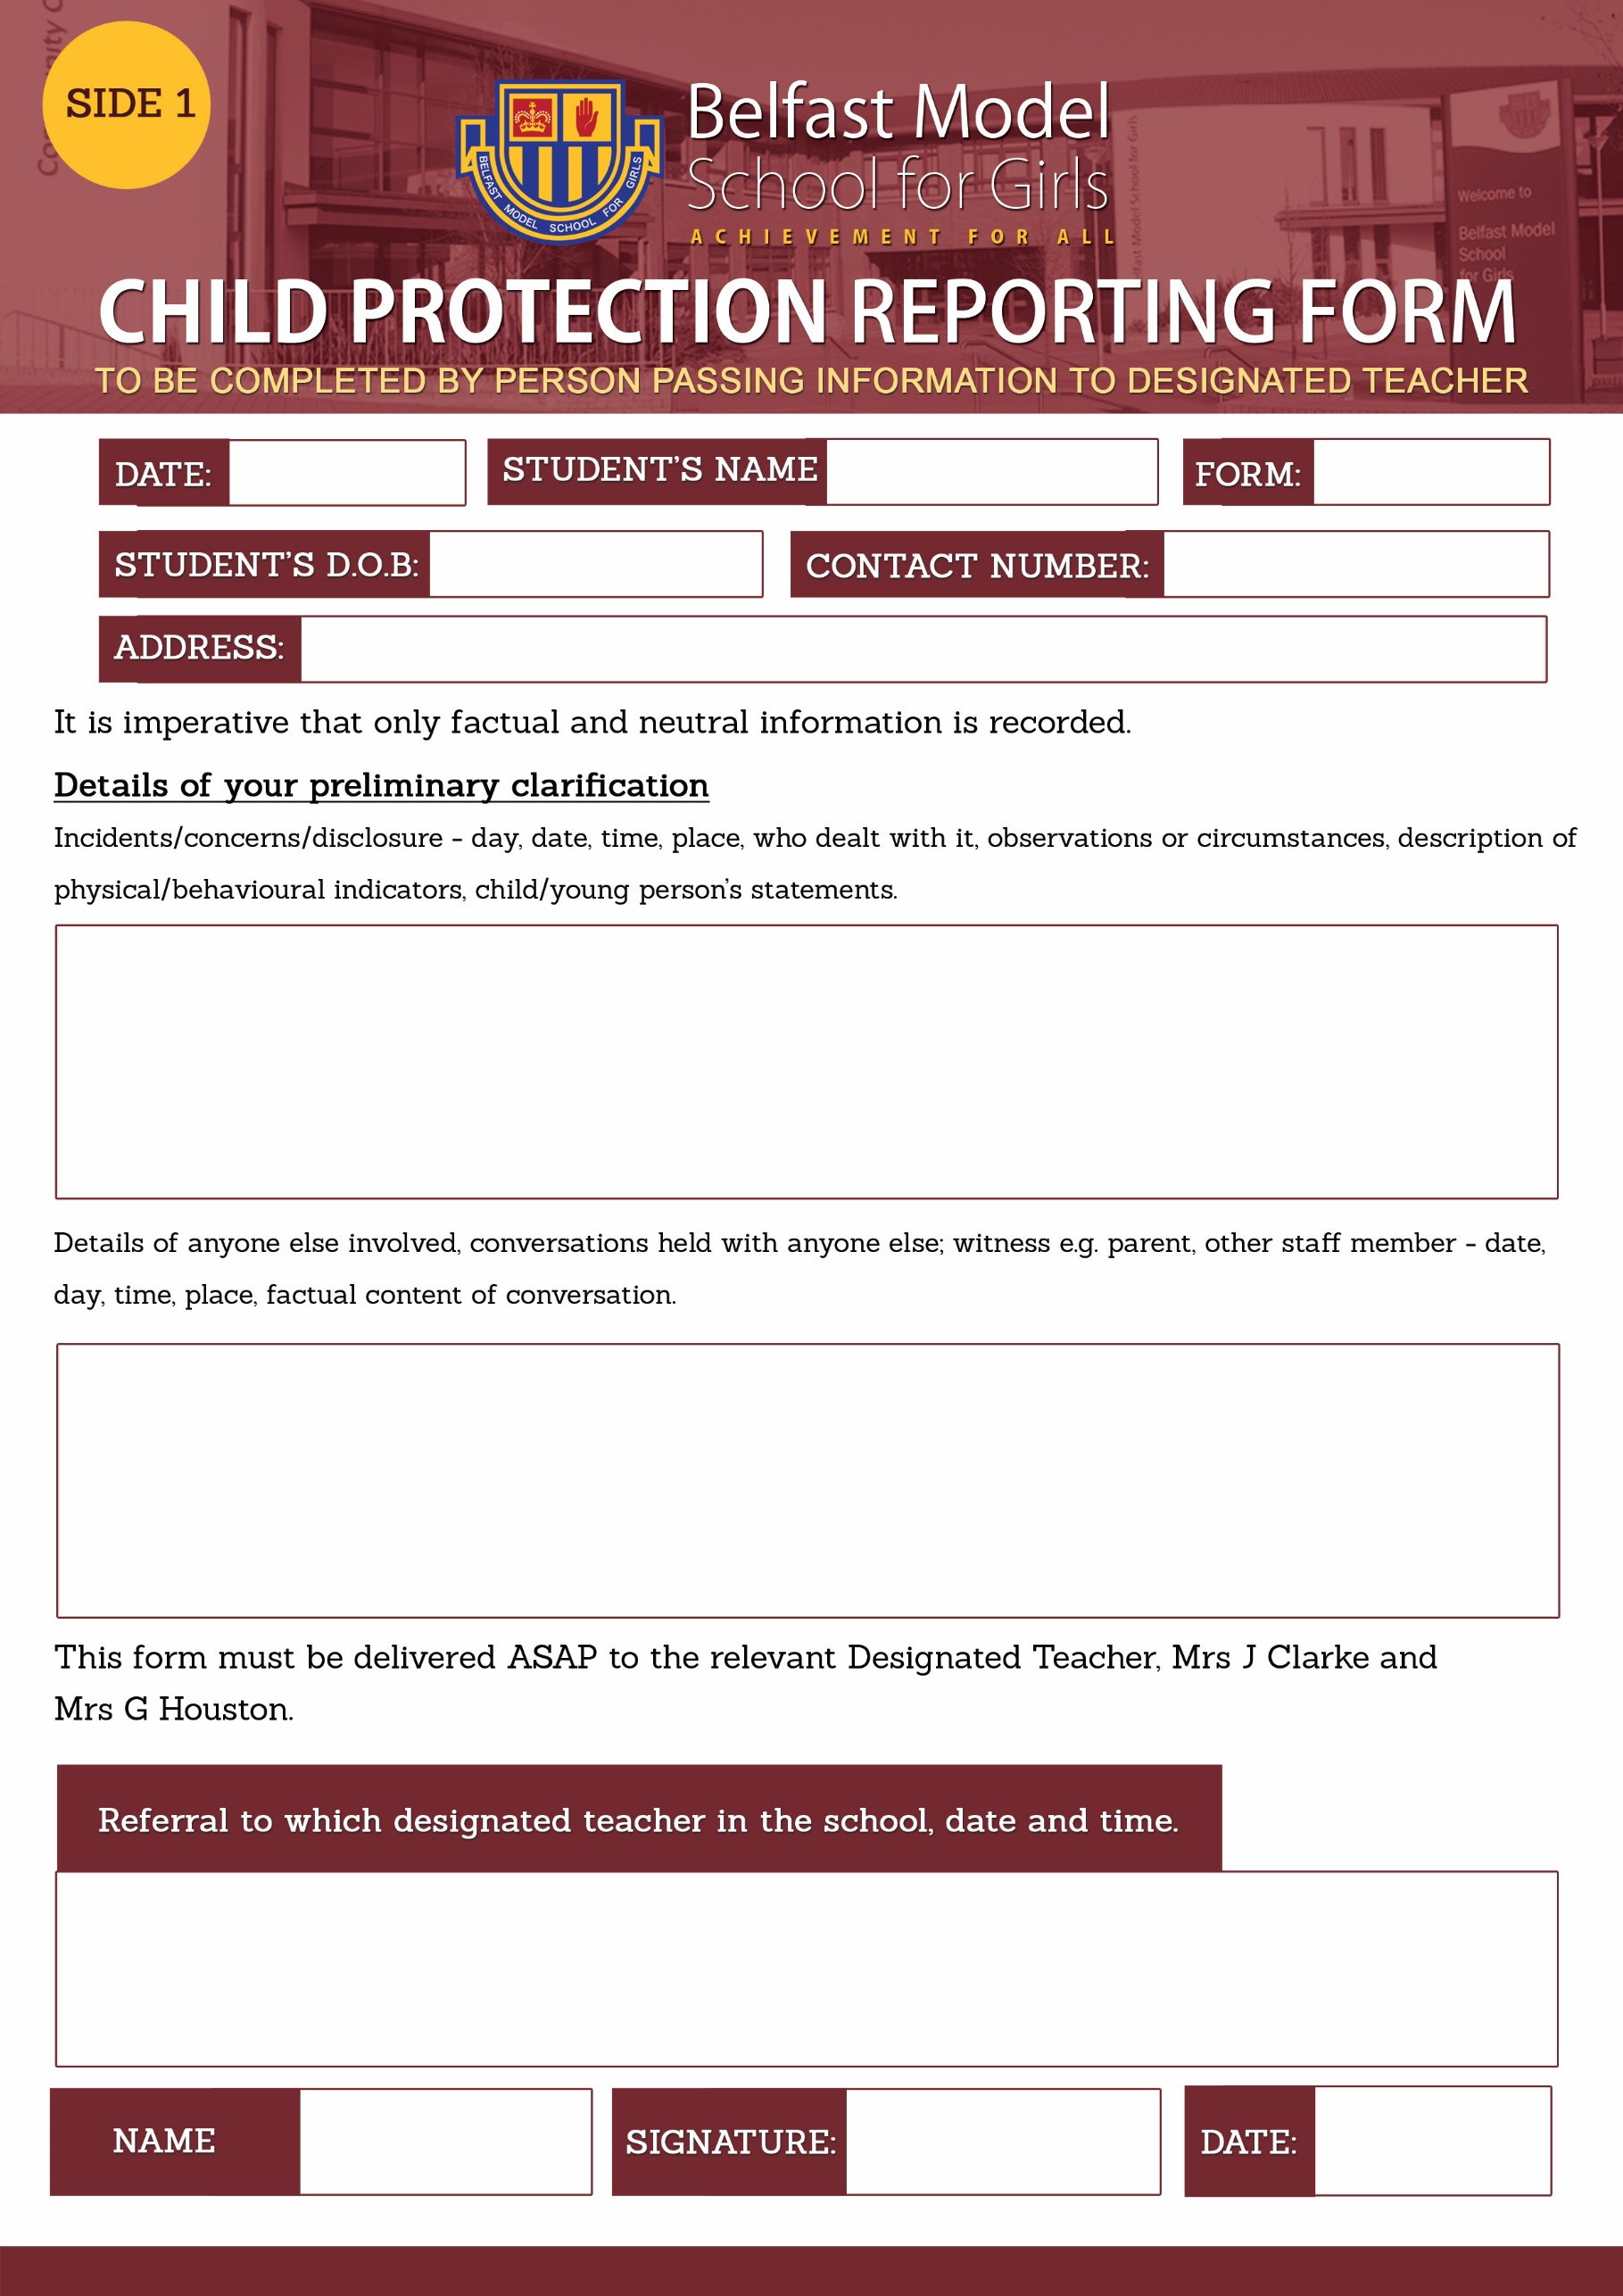
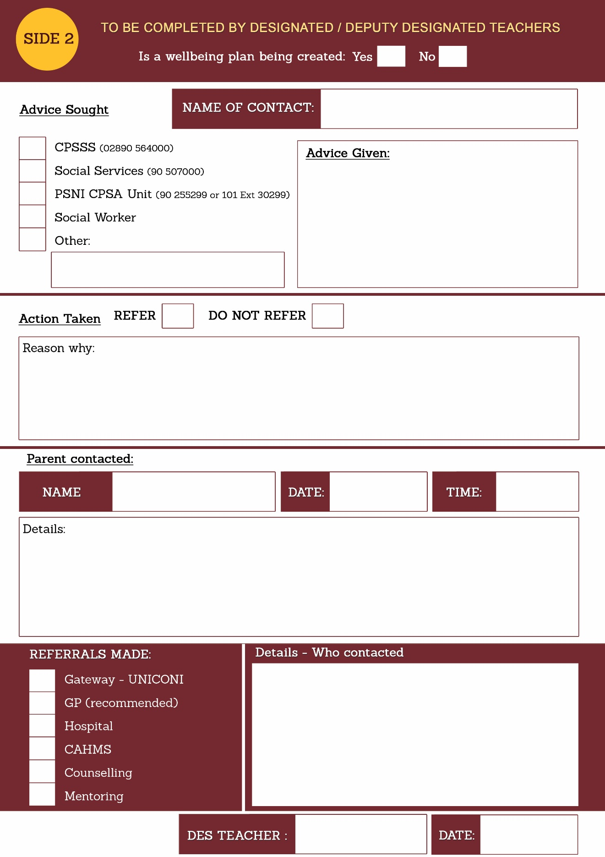

The Department of Education Disposal Schedule recommends that a staff file is retained for 7 years after leaving employment. In the case of child protection concerns the file should be retained for the time periods specified in the school Child Protection Records Retention and Destruction Policy.

