Emergency Management Plan
Belfast Model School for Girls

Critical Incident

Reviewed Sept 2021

TABLE OF CONTENTS

Introduction
1.1 | Overview
1.2 | Plan organisation
2.0 | Standardised emergency management
2.1 | Incident management team
2.2 | First aid personnel
2.3 | Other school staff
2.4 | Role of the emergency services
Emergency preparedness procedures
2.5 | Emergency accommodation plan
2.6 | Emergency communication protocol
2.7 | Emergency control centre
2.8 | Emergency evacuation kit
2.9 | Activation procedures
2.10 | Continuity of administration
2.11 | Training
2.12 | Post disaster actions
2.13 | Family reunification site
3.0 initial response to emergencies
3.1 | Identify type of emergency
3.2 | Identify level of emergency
3.3 | Determine immediate response actions
4.0 Immediate response actions
4.1 | Shelter-in-place
4.2 | Short-term shelter-in-place
4.3 | Lockdown
4.4 | Evacuate building
4.5 | Off-site evacuation
4.6 | All clear
4.7 | Initial response actions
5.0 Emergency procedures
5.1 | Abduction of a pupil
5.2 | Aircraft crash
5.4 | Armed assault on school property
5.5 | Biological or chemical release
5.6 | Bomb threat
5.7 | Building damage
5.8 | Bus accident
5.9 | Civil disturbance
5.10 | Contamination of food or water
5.12 | Dealing with pupil reactions
5.12 | Dealing with staff reactions
5.13 | Death of a parent
5.14 | Death of a pupil
5.15 | Death of a staff member
5.16 | Disorderly conduct
5.17 | Drug abuse
5.18 | Drug misuse incident
5.19 | Emergency accommodation plan
5.20 | Explosion
5.21 | Fire in surrounding area
5.22 | Fire on school grounds
5.23 | Flooding
5.24 | Fuel shortage
5.25 | Hostage situation
5.26 | Human influenza pandemic
5.27 | Injured school personnel
5.28 | Intruder on premises
5.29 | Motor vehicle crash
5.30 | Suicide
5.31 | Threats to staff
5.32 | Unlawful demonstration/walkout
5.33 | Utility failure
6.0 Other emergency information
6.1 | Board publications dealing with emergencies
6.2 | Alert system 1 (parents)
6.3 | Alert system 2 (school personnel)
6.4 | School plan and area map
6.5 | Emergency phone numbers
6.6 | Emergency drills
6.7 | Drill 1: Fire
6.8 | Drill 2: Shelter-in-place
Appendices
Appendix A – Forms
FORM A | Emergency hazard assessment
FORM B | Biological and chemical release checklist
FORM C | Bomb threat report
FORM D | Missing persons report
FORM E | Pupil release log
FORM F | Press release
FORM G | Emergency drill record
FORM H | Initial emergency record
FORM I | Pupil Emergency card
FORM J | Media Request
FORM K | Emergency management organisation chart
Appendix B alert systems
School personnel contact numbers
School external emergency contact list
Appendix C Maps
School Plan
Location Map
Appendix D Publications
Board publications
Bomb threats – emergency response procedures
Dealing with media during critical incidents
Fire prevention – good practice
Personal safety guidance
Suspicious packages – Anthrax
Appendix E Flowcharts and Diagrams
Emergency accommodation centre
Immediate emergency response actions
Bomb threat procedures for fire marshals, etc

1.0 Introduction

1.1 Overview

Emergencies are sudden and unexpected events that can cause death, injury and property damage. An emergency or crisis is an event that brings the ongoing schedule of activities to a standstill. An emergency, by its very nature, causes chaos that is seemingly not confinable. One of the most effective means of mitigating the effects of an emergency is to be prepared.

The purpose of this plan is to provide emergency preparedness and response instructions, information and guidelines to protect the safety and well-being of pupils and staff of the school at the time of an emergency. Specific objectives of this plan include:

- Protection of the safety, and welfare of pupils and staff;
- Provision of guidelines for a safe and co-ordinated response to emergency situations;
- Protection of the school facilities and property;
- Guidelines to restore normal conditions with minimal confusion in the shortest time possible; and
- Guidelines for co-ordination of off-site emergency operations resources.

This plan is intended to be flexible, and will be reviewed annually by the school. In the event of an emergency, the plan will be reviewed as soon as possible after the event to determine whether procedures in the plan were followed and whether they were adequate.

1.2 Plan organisation

The effective management of emergencies requires both adequate emergency preparedness and emergency response capabilities. This plan is organised into sex six sections. Section 2 deals with emergency preparedness, identifies the school’s emergency management team, and defines the roles and responsibilities of team members. Sections 3 and 4 present guidance for determining the nature and extent of an emergency and a series of initial response actions to be taken in a emergency. Section 5 provides detailed emergency response setting. Section 6 provides supplemental emergency information including contact information. Standard forms, site maps and other support information are contained in the Appendices.

2.0 Standardised emergency management

2.1 Incident management team

The incident management team is responsible for directing school emergency response activities.

Assignments

The incident management team is led by the Principal (incident manager) and also includes the school’s public information officer, the safety co-ordinator, and the agency liaison officer.

Incident manager: | Ms P Stuart
Public information officer: | Ms P Stuart
Safety co-ordinator: | Ms C McLaren and Amey
Agency Liaison officer: | Amey

The incident manager also directs the activities of all other teams.

Roles and responsibilities

Incident manager

The incident manager (Principal) is responsible for directing emergency operations and shall remain at the incident post to observe and direct all operations. Specific duties of the incident manager may include:

- Periodically assessing the situation.
- Directing the incident management team and all other emergency teams.
- Determining the need for, and requesting, outside assistance.
- Periodically communicating with the Education Authority (EA).

Public information officer

- The public information officer (PIO) is the official spokesperson for the school site in an emergency and is responsible for communicating with the media and delivering announcements. Specific duties of the public information may include:
- Periodically receiving updates and official statements from the incident manager.
- Maintaining a log of PIO actions and all communications.
- Periodically interacting with the media and the board’s information officer.
- Preparing statements for dissemination to the public.
- Monitoring news broadcasts about the incident and correcting any misinformation.
- Liaising with the officer in charge of the primary emergency services agency.

Safety co-ordinator

The safety co-ordinator is responsible for ensuring that all emergency activities are conducted in as safe a manner as possible under the circumstances that exist. Specific duties of the safety co-ordinator may include:

- Periodically checking with the incident manager for situation briefings and updates.
- Maintaining all records and documentation as assigned by the incident manager.
- Monitoring drills, exercises and emergency response activities for safety.
- Identifying safety hazards.
- Ensuring that responders use safety equipment.

Agency liaison officer

The agency liaison officer is responsible for co-ordinating the efforts of outside agencies such as Police and Fire by ensuring the proper flow of information between the incident manager and the agencies. Specific duties of the agency liaison officer may include:

- Periodically checking with the incident manager for situation briefings and updates.
- Maintaining all records and documentation as assigned by the incident manager.
- Briefing agency representatives on current situation, prioritie4s and planned actions.
- Ensuring co-ordination of efforts by periodically keeping the incident manager informed of agencies action plans and providing periodic updates to agency representatives as necessary.

2.2 First aid personnel

First aid personnel are responsible for ensuring that the first aid supplies are available and properly administered during an emergency.

Assignments

First aiders: | Louise Finlay
 | Rebecca Martin

Roles and responsibilities

The first-aiders are responsible for assessing injuries and administering necessary first aid as indicated during an emergency. Specific duties may include:

- Setting up a first aid area.
- Keeping accurate records of care given.
- Reporting deaths immediately to incident commander.

2.3 Other School Staff

Teaching staff

Teachers are responsible for the safe and orderly evacuation of pupils when instructed by the Principal or designee to do so. Teachers will ensure that pupils are accounted for and will check their designated area as indicated in the evacuation plan. Pupil record cards, attendance roll, etc are to be taken to the evacuation assembly area. If time permits, all appliances (cookers, heaters, etc) should be turned off. Doors and windows should be closed before leaving the classroom. Teachers will use the buddy system to group classes thereby releasing some teachers to designated jobs.

General office staff

General office staff will deal with routine enquiries from staff and will assist the Principal or designee during an emergency. Office staff will be responsible for general telephone communications, including notification of parents, at the direction of the Principal.

Amey/fm staff

Amey/fm staff are responsible for the security of the school site during an emergency. The Amey/fm manager will co-ordinate activities with the Principal as required identifying problems and reporting status. The Amey/fm manager is also responsible for contacting local utility companies (water, electricity, gas, and sewer) as needed. Other duties may include locking all external gates and doors; unlocking fates as appropriate; taking appropriate action to shut off gas, water and electricity; keeping staff and pupils out of buildings as necessary; contacting building maintenance as required.

Catering staff

Assist as directed with obtaining food and drink from other sources where appropriate.

2.4 Role of the emergency services

The emergency services are the principal partners in planning for a major incident. The roles of the Police, Fire Service and Ambulance Service in an emergency are detailed below.

Police

The primary areas of police responsibility at a major incident are:

- The saving of life in conjunction with the other emergency services;
- The co-ordination and communication between the emergency services, board and other organisations acting in support at the scene and to control sightseers and traffic through the use of cordons;

- Inner cordon: provides immediate security of the rescue zone, and potential crime scene.

- Outer cordon: Seals off an extensive controlled area surround the rescue zone. All access and exit points will be controlled and persons requesting access vetted. The control/command vehicles of the emergency services must be position between the inner and outer cordons.

- Traffic cordon: Deployed at or beyond outer cordon preventing vehicular access to the area surrounding the scene.

- The investigation of the incident and obtaining the securing of evidence in conjunction with other investigative bodies where applicable;
- The collation and dissemination of casualty information;
- The identification of the dead on behalf of the coroner;
- The prevention of crime;
- Short-term measures to restore normality after all necessary actions have been taken.

Fire Service

The primary areas of fire service responsibility at a major incident are:
- Life saving, through search and rescue;
- Rendering humanitarian services;
- Provide and or obtain specialist advice and assistance where hazardous materials are involved;
- Salvage and damage control including environmental control;
- The provision of specialist equipment e.g. pumps, rescue equipment and lighting;
- Safety management within the inner cordon (rescue zone).

Ambulance

The primary areas of ambulance service responsibility at a major incident are:
- To save life in conjunction with the other emergency services;
- To provide treatment, stabilization and care of those injured at the scent;
- To provide sufficient paramedic units;
- To establish effective triage points and systems and determine the priority evacuation needs of those injured;
- To provide a focal point at the incident for all NHS and other medical resources;
- To provide communication facilities for NHS resources at the scene, with direct communication links to hospitals, control facilities and any other agency as required;
- To nominate and alert the receiving hospitals for those injured;
- To maintain emergency cover throughout the area and return to a state of normality at the earliest time.

2.5 Emergency preparedness procedures

Management

- The Principal will annually conduct an emergency hazard assessment to evaluate unique site characteristics and conditions in the adjoining community that could cause an emergency incident. The emergency hazard assessment summary (Form A, Appendix A) should be used for this purpose.
- The Principal will designate primary and secondary incident control locations and ensure that these locations are identified in section 2.
- The Principal will ensure effective communication during an emergency.
- The Principal will ensure that all staff members are aware of their responsibilities and assignments as defined in this section.
- The Principal will ensure that emergency response actions are properly documented as they occur and that appropriate procedures are included in this plan.

Operations

The Principal will ensure that this plan includes procedures for the following:

- Administering first aid;
- Ensuring site security;
- Conducting damage assessments;
- Evacuation; and
- Pupil release operations.

The Principal will ensure that routine drills referenced in section 6.7 are conducted at the school to rehearse emergency response operations.

2.2.1 Emergency accommodation plan

In an Off-site evacuation the school will provide safe shelter to pupils and staff, e.g. community centres and church halls.

The Principal will seek out appropriate sites and will discuss their possible use as emergency accommodation with the property owners.

The following section criteria will be used in determining suitability.

- Space availability – can it accommodate all of the school pupils and staff?

- Parking – easy access for transport (board buses, cars, emergency services)

- Services available – toilets (i.e. suitable number, exclusive use of children, suitable for very young children); seating (adequate number and type); heating; light; and telephone access (for emergency communication)

- Access to building – is it open all the time, is it within walking distance?

The emergency accommodation sites for the school are:

- Carrs Glen Primary School - updated

- Ballysillan Leisure Centre - updated

2.5.2 Emergency communication protocol

Crisis communications plan checklist

- A school spokesperson has been designated for the crisis site. This person should be familiar with the school’s emergency plan.
- Fax numbers for local media have been programmed into the school’s fax machine
- Media contact numbers have been placed in an emergency evacuation kit.
- A media staging area has been determined. The site provides a good camera view of the school, yet is located away from response operations, the incident control centre, and the family reunification site.
- A location for media briefings has been chosen, which is the:

  - At the discretion of the Principal

- Fact sheets with background information about the school have been created.
- A system is in place to post updated press releases on the school’s web site during a crisis.

Communication with parents

Letters will:

- Be brief and accurate;
- Consider family wishes for privacy, particularly in the case of suicide.
- Include facts about the incident;
- State action taken by the school;
- Indicate school’s next step or give information indicating future plans;
- Give information on common reactions of children to trauma or death emphasizing that most reactions, even if distressing, are normal but may still be in need of support;
- Indicate where and when to seek further help within the school and externally;
- Invite ideas, information and feedback from parents in order to promote open channels of communication and to validate parents’ opinions and skills; and
- Advise if plans are being made for parents’ meetings. These allay fears if there is excessive anxiety e.g. about symptoms of meningitis or after suicide.

Press statements

Press statements should be as regular as up-dates are needed. They will include:

- Facts about the incident – what happened, when, where, who was involved, what has been done and what is planned;
- Affirmation that the school’s main concern is the health and safety of pupils and staff and that the school is working closely with the relevant authorities; and
- Expressions of the school’s sympathies to families or victims if there are deaths of injuries.

Press interviews

- The Principal, or school information officer will give press interviews;
- Journalists will be banned from the school premises.
- Statements will be checked by Governors, and if necessary, legal advisers.
- Advice will be sought from the board’s information officer.

2.5.3 Emergency control centre

Location: The main emergency control centres will be set up in the school.

- The primary emergency control centre will be set up in the General Office, GO1.

- The secondary emergency control centre will be the Amey/fm office G18E.

Access: During working hours, normal access arrangements will apply. Out of hours access is by arrangement with Amey fm.

Equipment: The designated area for the incident management team is well equipped to deal with the co-ordination of the school’s response to most emergency situations.

Communications: The school’s main telephone system will be designated for emergency use only. A number of mobile phones are also available.

Alternative location of the incident control centre: In the unlikely event of any accommodation in the school being unavailable for use arrangements have been made to relocate the incident control centre to the designated emergency accommodation site.

2.5.4 Emergency evacuation kit

The emergency evacuation kit will be taken from the school by the Principal or designated member of staff during an emergency evacuation. The kit will be regularly updated, and will be taken during evacuation drills. The emergency evacuation kit will be stored in an out sight location so as not be readily accessible by an offender such as a burglar.

The emergency evacuation kit will contain the following:

- A copy of the school’s emergency response plan;
- Pupil release forms;
- A copy of the school site plan;
- Emergency telephone contact lists;
- Copies of pupil and staff emergency contact information;
- First aid kit; and
- Emergency medical information regarding pupils.

2.5.5 Activation procedures

Notification of an emergency alert would come from a number of sources. The likely routes would be as follows:

- Internally via school’s reporting procedure;
- Switchboard operator (bomb threat);
- Emergency services (Fire, Police);
- Media sources; and
- Other agencies (Belfast City Council, Environmental Health, etc).

All alerts should be authenticated. If necessary a telephone number, which can be contacted to confirm the alert should be requested by the recipient of the message.

A decision will be made by the Principal, or if not available any other designated deputy, following an assessment of the situation, of the extent of the emergency plan response.

Within normal working hours the relevant incident control team members will be contacted via the school’s telephone system. Out of hours, members will be contacted on their mobile phone number. Following initial contact and dissemination of relevant information, individual team members will then contact any necessary members of staff from their department and initiate either an immediate response or standby. Notification of a hazard/event with the prospect of causing an emergency situation to develop, e.g. civil demonstration, severe weather warning, may necessitate a standby of staff.

2.5.6 Continuity of administration

In the case of a school building emergency situation, the decisions will be made by:

School telephone number: 02890718111
School fax number: 02890729451 or 02890714448

Position | Name | Mobile telephone number | Home telephone number
Principal | Ms P Stuart
Vice-Principal | Ms J Graham
Safety  co-ordinator | Ms C McClaren
Amey fm manager |  |  | -

2.5.7 Training

Training programmes can enhance overall school emergency preparedness by presenting ideas and response techniques consistent with emergency plans. Everyone who has been assigned a position or area of responsibility in the plan will receive appropriate briefing or training. Training will entail either short presentations related to any aspect of preparedness or simulations of real emergencies in which people will act their roles.

Training will be
- Provided to staff who have been assigned a position of are of responsibility;
- Conducted annually to ensure staff and pupils understand emergency procedures; and
- Include any changes to plans.

2.5.8 Post disaster actions

The school incident management team will meet as soon as possible after the emergency to determine a recovery plan. This will involve discussion of the actions to be taken with the Belfast Education and Library Board. As far as possible, the premises will be secured to prevent students, visitors and staff from re-entering, to deter looting and general sightseers, to minimize further damage and preserve forensic evidence. The objective is to maintain safety and to assist in salvage possibilities.

The school incident management team will maintain records of the location of staff and students moved to other schools and as far as possible determine if there is any necessity for post-traumatic stress counselling.

If any person involved in the emergency does require counselling, only qualified and competent experts will be consulted. The school incident management team and office staff will contact disaster recovery specialist and other staff as felt appropriate to assist in the salvage of any equipment and information. This will only take place once the premises are determined to be safe by the emergency services.

A family reunification site will be set up as appropriate to reunite parents or guardians with pupils. A member of the school office staff or other designated person will:

- Greet parents;
- Verify their identity;
- Dispatch pupil runners to the assembly area to escort pupils whose parents have come to reclaim them;
- Confirm that pupils recognize the adults who come to claim them;
- Require adults to sign pupil out of school; and
- Complete student release log.

3.0 Initial response to emergencies

When an emergency situation occurs, school personnel must quickly determine what initial response actions are required. Determining the appropriate actions to take is a three-step process: identify the type of emergency; identify the level of emergency; and determine immediate actions that may be required. Each of the steps is discussed in the following sections. Procedures for specific response actions are provided in sections 4 and 5.

3.1 Identify type of emergency

The first step in responding to an emergency is to determine the type of emergency that has occurred. Emergency procedures for different types of emergencies are provided in section 5.

3.2 Identify level of emergency

The second step in responding to an emergency is to determine the level of the emergency. Emergency situations can range from a small fire, to major bomb damage. To assist in classifying emergency situations, a three-tiered rating system is described below.

Level 1 emergency: A minor emergency that is handled by school personnel without assistance from outside agencies, e.g. a temporary power outrage, or a minor injury in the playground.

Level 2 emergency: A moderate emergency that requires assistance from outside agencies, such as a fire, or a suspected act of terrorism.

Level 3 emergency: A major emergency event that requires assistance from outside agencies such as civil disturbance, or a large-scale act of terrorism. For Level 3 emergencies, it is important to remember that the response time of outside agencies may be seriously delayed.

3.3 Determine immediate response actions

Once the type and extent of emergency have been identified, school personnel can determine if an immediate response action is required. The most common immediate response actions initiated during school emergencies are:

- Shelter-in place
- Lockdown
- Evacuate building
- Off-site evacuation
- All clear

Procedures for each of these are included in Section 4.0.

4.0 Immediate response actions

4.1 Shelter-in-place

This is a procedure, which allows the school to continue with the normal school day, but curtails outside activity and allows no unauthorised personnel into the building. Most commonly used when incident is occurring outside school building, on or off school property.

Description of action

- The Principal will announce that Shelter-in-place has been implemented.

- If inside, teachers will keep pupils in the classroom until further instructions are given.

- If outside, pupils will proceed to their classrooms, if it is safe to do so. If not, teachers will direct pupils into nearby classrooms or school buildings (e.g. dining hall, gymnasium). Teachers should consider the location and proximity of the identified hazard and, if necessary proceed to an alternative indoor location.

- Teachers are responsible for individual classrooms and Amey/fm/assigned staff will assist as needed by locking, and securing all exterior doors, and entrances; shutting down any ventilation systems, turning off local fans, and turning off sources of ignition, such as pilot lights.

- Amey/fm /Assigned staff will monitor the main entrance and allow only authorised personnel into building.

4.2 Short-term shelter in place

This is a procedure whereby the entire school population is moved to a single (or multiple) location(s) in the school, depending on building population. Most commonly used during bomb threats and weather emergencies.

Description of action

- The Principal will announce that a Short-term shelter-in-place has been implemented.

- Teachers, staff and pupils will proceed to their designated shelter in place.

- Teaches will take their class registers with them and take attendance once the class is assembled in a safe location.

- Depending on emergency, the Amey/fm manager or assigned staff will use “barricades” to close off school driveways and parking areas.

- The Principal and designees will assist emergency personnel as necessary.

- If long-term shelter is needed, the Principal will consult with the board.

4.4 Lockdown

This procedure is used when there is an immediate and imminent threat to the school building population. School staff and pupils are secured in the rooms they are currently in, and no one is allowed to leave until the situation has been curtailed.

The difference between Shelter-in-place and Lockdown is that the former allows for free movement of pupils within the building.

Description of action

- The Principal will give the Lockdown signal, (code, phrase or audible sound from speakers).

- If inside, teachers/staff will follow preset instructions to secure doors, turn out lights, cover windows, pull shades and move pupils out of line of sight of door windows, if it appears safe to do so.

- If outside pupils will proceed to their classrooms, if it is safe to do so. If not, teachers or staff will direct pupils into nearby classrooms or school buildings (e.g. dining hall, gymnasium).

- Teachers and pupils will remain in the classroom or secured area until the Principal or emergency personnel give further instructions.

- Teachers are not allowed to open doors for anyone under any circumstances.

- The front entrance is to be locked and no visitors other than appropriate emergency personnel have to be allowed on school grounds.

4.4 Evacuate building

This action is taken after the decision is made that it is unsafe to remain in the building.

Description of action

- The Principal will if appropriate, announce that it is necessary to evacuate the buildings.

- The Principal will authorise fire alarm activation.

- Teachers will instruct pupils to evacuate the building, using designated routes, and assemble in their assigned assembly area.

- Teachers will take their class registers when leaving the building and take attendance once the class is assembled in a safe location

- Once assembled, teachers and pupils will stay in place until further instructions are given.

4.5 Off-site evacuation

This action is taken after a decision is made that it is unsafe to remain on the campus and evacuation to an off-site assembly area is required.

Description of action

- The Principal will announce by agreed means of communication that is necessary to begin an off-site evacuation of the school building.

- The Principal will determine the safest method for evacuation the school ground. This may include the use of board and school buses or simply waling to the designated off-site location. The off-site assembly areas are indicated on the map in Appendix C.

- Teachers will take the class register when leaving the building and take attendance once the class is assembled in a pre-designated safe location.

- Once assembled off-site, teachers and pupils will stay in place until further instructions are given.

- In the event clearance is received from the appropriate agencies, the Principal may authorise pupils and staff to return to the classrooms.

4.6 All clear

This action is taken to notify teachers that normal school operations can resume.

Description of action

- The Principal will use an agreed form of communication to announce that the emergency is over and it is safe to return to the classroom and resume normal operations.

- This action signified that the emergency is over.

- If appropriate, teachers should immediately begin discussions and activities to address pupils’ fears, anxieties and other concerns.

4.7 Initial response actions

Within first hour

- Carry out quick assessment of immediate response required.
- Select and set up control arrangements.

Within hours if practicable

- Call a staff meeting to give information
- Inform pupils in a sensitive way – small groups if appropriate.
- Arrange a debriefing meeting for staff involved in the incident.
- Arrange a debriefing meeting for pupils involved in the incident.

Next few days, could go on longer

- Facilitate support for high-risk pupils and staff.
- Funerals, rites and memorials.

As soon as possible for as long as necessary

- Decide and agree a range of response and support measures; these have the potential to run for many weeks/months.

5.0 Emergency procedures

This section describes the specific procedures school staff will follow during the following emergencies:

- Abduction of a pupil
- Aircraft crash
- Animal disturbance
- Armed assault on school property
- Biological or chemical release
- Bomb threat
- Building damage
- Bus accident
- Civil disturbance
- Contamination of food or water
- Dealing with pupil reactions
- Dealing with staff reactions
- Death of a parent
- Death of pupil
- Death of staff member
- Disorderly conduct
- Drug abuse
- Drug misuse incident
- Emergency accommodation plan
- Explosion
- Fire in surrounding are
- Fire on school grounds
- Flooding
- Fuel shortage
- Hostage situation
- Injury
- Intruder on premises
- Motor vehicle crash
- Suicide
- Threats to staff
- Unlawful demonstration/walkout
- Utility failure

It is important to note that school mangers are responsible for the health and safety of pupils and staff during an emergency. Although the following procedures refer to specific actions, school managers must exercise discretion in implementing standardised procedures and should consider modifications as necessary to assure the health and safety of all personnel during an emergency.

5.1 Abduction of a pupil

- Before implementing the procedures outlined below, it is important to make sure that an actual abduction has occureed. If an actual abduction has occurred:

- The Principal will notify the abducted child’s parent(s).

- The Principal will notify the board.

- The Principal will complete a missing person’s report form.

- The school’s information officer will liaise with the media as required.

- The Principal will send a letter to parents informing them of the incident and that counselling services will be made available to their child.

5.2 Aircraft crash

This procedure addresses situations involving an aircraft crash on or in proximity to school property. If a crash results in a fuel or chemical spill on school property, refer to section 5.5, biological or chemical release. If a crash results in a utility interruption, refer to section 5.3.1, loss or failure of utilities.

Procedure

- The Principal or designee will initiate appropriate immediate response actions, which may include, Shelter-in-place, Evacuate building, or Off-site evacuation as described in section 4.0.

- If the Principal or designee issues the Evacuate building action, staff and pupils will evacuate the buildings using prescribed routes or other safe routes to the assembly area.

- In the event of an evacuation, teachers will bring their pupil register and take attendance at the assembly area to account for pupils. Teachers will report any missing pupils.

- The Principal or designee will call “999” and will provide the exact location (building or area) and nature of emergency.

- The Amey/fm manager will secure the crash area to prevent unauthorised access until the arrival of emergency services.

- First-aiders will check injuries to provide appropriate first aid.

- The Principal or designee will contact the board.

- Any affected areas will not be reopened until the emergency services provide clearance and the Principal or designee issues authorisation to do so.

- If it is unsafe to remain on campus, the Principal or designee will initiate an Off-site evacuation, as described in section 4.0, if warranted by changes in conditions.

5.3 Animal disturbance

This procedure is implemented when the presence of a dog, or other animal threatens the safety of pupils and staff.

Procedure

- The Principal or designee will initiate appropriate immediate response actions, which may include Lockdown or Evacuate building as described in section 4.0.

- Upon discovery of an animal, staff members will attempt to isolate the animal from pupils, if it is safe to do so. If an animal is outside, pupils will be kept inside. If the animal is inside, pupils will remain outside in an area away from the animal. Closing doors, or locking gates will be used as a means to isolate the animal.

- If additional outside assistance is needed, the Principal designee will call “999”, Environmental Health Department and provide the location of the animal and nature of emergency.

- If a staff member or pupil is injured, the school first-aider and parent will be notified and the injured person taken to hospital if necessary.

- The Principal or designee will initiate an Off-site evacuation as described in section 4.0, if warranted by changes in conditions at the school.

5.4 Armed assault on school property

An armed assault on school property involves one or more individuals who attempt to take hostages or cause physical harm to pupils and staff. Such an incident may involve individuals who possess a gun, a knife, or other harmful device.

Procedure

- Upon first indication of an armed assault, personnel should immediately notify the Principal or designee.

- The Principal or designee will initiate the appropriate immediate response actions, which may include Shelter-in-place, Lockdown, Evacuate building or Off-site evacuation as described in section 4.0.

- The Principal or designee will call “999”, and provide the exact location and nature of the incident. The Principal or designee should designate a person to remain on Line wit Police if safe to do so.

- The Principal or designee should contact the board.

- Staff should take steps to calm and control pupils and if safe to do so, attempt to maintain separation between pupils and the perpetrator.

- Staff should maintain order in all areas of assembly or shelter and should await the arrival of the Police.

- After the Police have dealt with the situation, the Principal or designee will conduct a headcount of pupils and staff, and will notify the Police of any missing persons.

- The school’s first-aiders will work with the emergency services to ensure injured pupils and members of staff receive medical attention.

- The Amey/fm manager will work with the Police to control all points of entry to the school.

- The Principal or designee will prepare a list of verified casualties, and the locations to which they were transported. The Principal or designee will confer with office staff to ensure the notification of parent and family members.

- All media enquiries will be recorded on the media report form and referred to the school’s designated public information officer and or the board’s information officer.

- The Principal or designee will debrief staff.

5.5 Biological or chemical release

A biological or chemical release is an incident involving the discharge of a biological or chemical substance in a solid, liquid, or gaseous state. Such incidents may also include the release of radioactive materials. Common chemical threats within or adjacent to schools include the discharge of acid in school, or an explosion in a nearby oil refinery or other chemical plant.

The following indicators may suggest the release of a biological or chemical substance: multiple victims suffering from watery eyes, twitching, choking or loss of co-ordination, or having trouble breathing. Other indicators may include the presence of distressed animals or dead birds.

This procedure deals with three possible scenarios involving the release of chemical substances: scenario 1 – substance released into a room or a building; scenario 2 – substance released outdoors and localised; and scenario 3 – substance released in surrounding community. It is necessary to first determine which scenario applies and then implement the appropriate response procedures listed below.

Procedure

Scenario 1: Substance released inside a room or building

- The Principal or designee will initiate the Evacuate building action as described in section 4.0. Staff will use designated routes or other alternative safe routes to an assigned assembly area, located upwind of the affected room or building.

- The Principal or designee will call “999” and will provide the exact location (e.g. building, room, area) and nature of emergency.

- The Principal or designee will notify the board of the situation.

- The Principal or designee will instruct the Amey/fm manager to isolate and restrict access to potentially contaminated areas.

- The Amey/fm manager will turn off local fans in the are of release, and close the windows and doors.

- Persons who have come into direct contact with hazardous substances should have affected areas washed with soap and water. If possible, immediately remove and contain contaminated clothes. Do not use bleach or other disinfectants on potentially exposed skin. Individuals that have been contaminated “topically” by a liquid should be segregated from unaffected individuals (isolation does not apply to widespread airborne releases). The emergency services will assess the need for medical attention.

- The office staff will prepare a list of all people in the affected room or contaminated area, specifying those who may have had actual contact with the4 substance. The office staff will provide the list to the Principal or designee, and the emergency response personnel.

- The Principal or designee will complete the biological and chemical release response checklist (Form B, Appendix A)

- Any affected areas will not be reopened until the appropriate agencies provide clearance, and the Principal or designee gives permission to do so.

Scenario 2: Substance released outdoors and localised.

- The Principal or designee will immediately direct staff to remove pupils from the affected area to an area upwind from the release. The Principal or designee will, if necessary, initiate the Evacuate building action as described in section 4.0.

- The Amey/fm manager will establish a safe perimeter around the affected area and ensure personnel do no re-enter the area.

- The Principal or designee will call “999” and will provide the exact location and nature of emergency.

- The Principal or designee will notify the board of the situation.

- The Amey/fm manager will turn off local fans in the area of release and close the windows and doors.

- Persons who have come into direct contact with hazardous substances should have affected areas washed with soap and water. If possible, immediately remove contaminated clothes. Do not use bleach or other disinfectants on potentially exposed skin. Individuals that have been contaminated “topically” by a liquid should be segregated from unaffected individuals (isolation does not apply to widespread airborne diseases). A first-aider should assess the need for medical attention.

- The office staff will prepare a list of all people in areas of contamination, especially those who may have had actual contact with the substance. The office staff will provide the list Principal and the emergency response personnel.

- Any affected areas will not be re-opened until the emergency services provide clearance and the Principal gives authorisation to do so.

Scenario 3: Substance released in surrounding community

- If the Principal or local authorities determine a potentially toxic substance has been released to the atmosphere, the Principal will initiate Shelter-in-place as described in section 4.0.

- Upon receiving the Shelter-in-place notification, the Amey/fm manager will notify teachers, etc. to turn off fans in the area; close and lock doors and windows; seal under doors with wet towels, etc. if possible; and turn off sources of ignition, such as pilot lights.

- Staff and pupils located outdoors will be directed to proceed immediately to nearby classrooms or buildings (e.g. school canteen). Teachers should communicate their locations to the Principal by phone or other means without leaving the building.

- The Principal will contact the emergency services, if necessary and provide the exact location and nature of emergency.

- The Principal will notify the board.

- The Principal will monitor information concerning the incident via the radio or television.

- The school will remain in a Shelter-in-place condition until the emergency services provide clearance, or staff are otherwise notified by the Principal.

5.6 Bomb threat

- Response to a bomb threat is initiated upon the discovery of a suspicious package on school property or receipt of a threatening phone call that may present the risk of an explosion.

Procedure

- If the threat is received by telephone, the person receiving the call should attempt to keep the caller on the telephone as long as possible and alert someone else to call “999” – telling the operator, “This is (state name) from (state school). We are receiving a bomb threat on another line. The number of that line is (state phone number.”)

- The person answering the threat call should ask the following questions, record the answers on the bomb threat report form (Form C, Appendix A), and then immediately inform the Principal:

- When is the bomb going to explode?
- Where is it?
- What will cause it to explode?
- What kind of bomb is it?
- Who are you?
- Why are you doing this?
- What can we do to stop the bomb from exploding?
- How can you be contacted?

- The Principal will direct the evacuation control officers to search for suspicious packages, boxes, or foreign objects. While conducting the search, all mobile phones, pagers and hand held radios will be turned off since many modern day explosive devices can be triggered by radio frequencies.

- After the search the Principal will determine the appropriate immediate response actions to announce, which may include, Lockdown, Evacuate building, or Off-site evacuation as described in section 4.0.

- When a suspicious object is found, (no attempt should be made to examine the object), the Principal shall issue the Evacuate building action. Staff and pupils will evacuate the building using the prescribed routes or other safe routes to the assembly area.

- In the event of an evacuation, teachers will bring their pupil register, and take attendance at the assembly area to account for their pupils. Teachers will report any missing pupils.

- The Principal will call “999”, if not already done, and will provide the exact location (e.g. building, room, area) of the potential bomb if known.

- The Principal will notify the board.

- School activities will not resume until the emergency services have checked the affected building and deemed them to be safe. The Principal will give the agree All clear signal when appropriate.

- The Principal will initiate an Off-site evacuation as described in section 4.0, if warranted by changes in conditions.

5.7 Building damage

The school building may suffer either minor or major damage as a result of a bomb, fire, or gas explosion, etc. The procedures to be followed are:

Minor or little damage – Pupils can re-enter building

- The Principal will initiate Off-site evacuation or give the agreed All clear signal as appropriate.

- The Principal will contact the board’s property services section to report the damage.

- The Principal will notify the parents of the incident by letter if appropriate.

Major or Extensive Damage – Pupils Cannot Re-enter Building

- The Principal will initiate Off-site evacuation.

- The Principal will initiate the emergency accommodation plan.

- If appropriate, the Principal will dismiss the school.

- The Principal will contact the board.

- The school’s information officer will prepare a media statement as required.

- After the crisis has been managed and an emergency situation no longer exists, the school and board will determine what action is required.

5.8 Bus accident

This procedure is for the use of bus drivers and school Principals in the event of a serious bus accident, or other emergency that occurs while pupils are on a field trip or being transported to or from school. This procedure deals with two possible scenarios: scenario 1 – serious bus accident or bus fire; and scenario 2 – bus accidents on weekend trips.

Procedure

Scenario 1: Serious accident or bus fire

- The driver should park the bus in a safe location, set the emergency brake and turn off the ignition.

- The bus driver or escort should evacuate the bus in the event of a fire.

- The bus driver will check for injuries, and provide appropriate first aid.

- The bus driver should call “999”, and provide exact location of the bus and wait for emergency services.

- The bus driver should contact the Principal and transport section as required to report location and condition of pupils.

- The Principal will determine what additional appropriate notification(s) should be made, and will brief the board.

- The bus driver will stay with the disabled bus until help arrives.

- The bus driver will account for all pupils and staff throughout the emergency and will complete an accident report form.

Scenario 2: Accidents occurring on weekend trips

- The bus driver will call “999” if necessary and provide exact location and nature of emergency.

- The driver will contact the Principal to report location and condition of pupils.

- The bus driver or escort will check for injuries and provide appropriate first aid.

- The Principal will determine what additional appropriate notification(s) should be made and will brief the school information officer and the board.

- The Principal or designee will report to the scene, meet the bus at the school, or go to the hospital depending on the degree of injuries and the location of the accident.

5.9 Civil disturbance

- A civil disturbance is an emergency caused by an action of a person or persons, which require an immediate response by school officials.

- Procedure

- At the beginning of an actual or potential disturbance, obtain the following information. Specific location, what time disturbance began, how many persons involved, what is taking place, purposes/intention of the group.

- The Principal or designee will contact the board.

- The Principal will, if conditions warrant, close the school if it can be achieved without risk to pupils and staff.

- In consultation with the emergency services, the Principal will authorise the re-opening of the building.

5.10 Contamination of food or water

This procedure should be followed if school personnel report suspected contamination of food or water.

Procedure

- The Principal or designee will arrange for the isolation of the suspected contaminated food/water to prevent consumption and will restrict access to the area.

- The Principal or designee will notify the Environmental Health Department and the board.

- Office staff will make a list of all potentially affected pupils and staff and will provide the list to responding authorities.

- The school’s first-aider will assess the need for medical attention and provide first aid as appropriate.

- Office staff will maintain a log of affected pupils and staff and their symptoms, the food/water suspected of contamination, the quantity of products consumed, and other pertinent information.

- The Principal or designee will consult with the Environmental Health Officers before the resumption of normal operations.

- The Principal will notify parents of the incident, as appropriate.

5.11 Dealing with pupil reactions

The following procedure lists some of the steps that may be used to deal with pupil reactions to various emergency situations.

Procedure

- The Principal will issue a statement to the entire school to provide accurate information and reassurance.

- Teachers will be available for individual and or classroom discussion.

- The Principal will send a letter home to parents to inform them of the procedures that were implemented since the emergency situation and of the availability of counselling services. Parents will be invited to contact the school if their child appears to need additional support.

- If appropriate, concrete activities should be planned such as sending cards, letter writing etc.

- Pupils needing additional help to deal with feelings and concerns will be referred to the board psychologist.

5.12 Dealing with staff reactions

The following procedure lists some of the steps that may be used to deal with staff reactions to varying emergency situation.

Procedure

- The Principal will inform all staff of available and appropriate information regarding the incident by selected means; e.g. memo. Staff should be kept up to date with developments and informed of any arrangements.

- The Principal will seek help from the board’s welfare officer to assist staff members if appropriate.

- If appropriate concrete activities should be planned such as sending cards, letter writing etc.

5.13 Death of parent

This procedure should be used in an emergency situation when both parents die, or if the child lived in a single-parent household and that parent dies during the school day.

Procedure

- The Principal should be notified in the first instance.

- The Principal will arrange for the provision of immediate in-house pastoral support to the pupil(s).

- The Principal will inform other Principals if siblings attend different schools.

- The Principal will contact the pupil(s) grandparents, uncles and aunts (if known) and follow their instructions.

5.14 Death of pupil

This procedure deals with two possible scenarios: Scenario 1 – Death of pupil in school; and Scenario 2 – Death of pupil out of school.

Procedure

Scenario 1: Death of pupil in school

- The first person on the scene will apply first aid if appropriate and call an ambulance.

- The Teaching staff will remove the other pupils from the classroom.

- The Principal will be notified.

- The Principal will contact:
  - Parents
  - The Board
  - Other Principals if siblings attend other schools.

- The Principal will notify all school staff of the incident by memo or staff meeting.

- The Principal will initiate appropriate strategies for dealing with pupils and staff.

Scenario 2: Death of pupil out of school

- The Principal should be notified immediately.

- The Principal will notify all school staff of the incident by memo or staff meeting.

- The Principal will initiate appropriate strategies for dealing with pupils.

- The Principal will notify the board’s welfare officer, education welfare officers and psychologists, if appropriate.

- The Principal will notify other Principals if siblings attend other schools.

5.15 Death of staff member

This procedure deals with two possible scenarios: scenario 1 – Death of staff member in school; and scenario 2 Death of staff member out of school.

Procedure

Scenario 1: Death of staff member in school

- The first person on the scene should apply first aid and if appropriate and call an ambulance.

- A teacher should remove pupils from the classroom.

- The Principal should be notified.

- A member of staff should remain with the classroom pupils to help them deal with their reactions.

- The Principal should contact the next of kin.

- The Principal should then notify other staff members and the board.

- The Principal should notify the parents of the pupils in the class via a letter.

Scenario 2: Death of staff member out of school

- The family should notify the Principal.

- The Principal should then notify staff members.

- The Principal should notify the parents of the pupils in the deceased’s class via letter.

5.16 Disorderly conduct

Disorderly conduct may involve a pupil or staff member exhibiting threatening or irrational behaviour. If the perpetrator is armed, refer to section 5.4, armed assault.

Procedure

- Upon witnessing a disorderly conduct, staff should take steps to calm and control the situation and attempt to isolate the perpetrator from other pupils and staff, if it is safe to do so.

- Staff will immediately notify the Principal.

- The Principal will initiate the appropriate immediate response actions, which may include Shelter-in-place, Lockdown, Evacuate building or Off-site evacuation as described in section 4.0.

- The Principal will call the Police, if deemed appropriate and provide the exact location and nature of the incident.

- If an immediate threat is not clearly evident, the Principal or a staff member may attempt to diffuse the situation. Approach the perpetrator in a calm, non-confrontational manner and request he or she leaves the school grounds. Avoid any hostile situations.

- If the perpetrator is a pupil, an attempt should be made to notify the family. (Family members may provide useful information on handling the situation)

- The Principal will notify the board of the situation.

5.17 Drug abuse

Pupils’ use, possession, or trafficking of drugs for non-medical purposes on or in school property, or at school-associated activities is strictly prohibited. This section addresses three possible scenarios:

Scenario 1 – Pupil exhibiting behaviour associated with drug abuse;
Scenario 2 – Pupil found in possession of unknown substance;
Scenario 3 – Suspected drug abuse at authorised out of hours activities.

Reference should be made to the Department of Education’s guidance on drugs, which was issued in May 2004. Further advice and guidance is available from the board’s drugs education team.

Procedure

Scenario 1: Pupil exhibiting behaviour associated with drug abuse

- The Principal should be notified.

- The Principal shall contact the school nurse and the parent or legal guardian.

- If necessary the Principal shall call “999” and provide details of the situation to the relevant emergency services (Police, Ambulance).

- The Principal shall confer with the parents.

Scenario 2: Pupil found in possession of unknown substance

- The teacher shall accompany the pupil to the Principal’s office with the substance.

- The Principal shall contact the Police.

- The Principal shall surrender the substance to the Police for identification.

- The Principal shall contact the parents.

Scenario3: Suspected drug abuse at authorised out of hours activities

- The teacher in charge shall immediately inform the Principal.

- The Principal shall take the necessary steps as outlined above.

- In an emergency, the teacher in charge will take necessary action.

- The teacher in charge will inform the Principal immediately.

5.18 Drug misuse incident

This section deals with the action to be taken when a pupil suffers from a drug overdose. Reference should be made the Department of Education’s guidance on drugs, which was issued in May 2004. Further advice and guidance is available from the Board’s drugs education team.

Procedure

- The teacher will make the area safe for all pupils.

- The teacher will apply First Aid.

- The teacher will inform the Principal immediately.

- The teacher will, if possible, secure a sample of the substance taken and make available to the emergency services for identification.

- The Principal will notify the relevant emergency services (Police, Ambulance).

- The Principal will contact the pupil’s parents.

- The Principal will initiate any additional action required.

- The Principal will notify the board of the situation.

5.20 Explosion

This section addresses three possible scenarios involving an explosion or risk explosion:

Scenario 1 – Explosion on school property;
Scenario 2 – Risk of explosion on school property;
Scenario 3 – Explosion or risk of explosion in a surrounding area.

It is necessary to first determine which scenario applies and then implement the appropriate response procedures.
For bomb threats, refer to section 5.6.

Procedure

Scenario 1: Explosion on school property

- In the event of an explosion, the Principal will consider the possibility of another imminent explosion and take appropriate action.

- After the explosion, the Principal will initiate appropriate immediate response actions, which may include Shelter-in-place, Evacuate building or Off-site evacuation as described in section 4.0. Evacuation may be warranted in some buildings and other buildings may be used as a shelter.

- In the event of an evacuation, staff and pupils will use prescribed routes or other safe routes and proceed to the assembly area.

- In the event of an evacuation, teachers will bring their attendance register to account for pupils at the assembly area.

- The Principal will call “999” and will provide the exact location (e.g. building, room, area) and nature of emergency.

- The school First-aiders will check for injuries and provide appropriate first aid.

- Staff should attempt to suppress fires with extinguishers.

- The Amey/fm manager will notify the appropriate utility company of any damage to water lines, sewers, power lines and other utilities.

- The Principal will notify the board of the situation.

- The Principal will contact the property services section of the board to ensure that buildings are safe for re-occupancy.

- Any areas affected by the explosion will not be re-opened until the appropriate agencies provide clearance and the Principal give authorisation to do so.

- The Principal will initiate an Off-site evacuation as described in section 4.0 if warranted by changes in conditions.

Scenario 2: Risk of Explosion on school property

- The Principal will initiate appropriate immediate response actions, which may include Shelter-in-place, Evacuate building, or Off-site evacuation as described in section 4.0

- If the Principal issues evacuate building action, staff and pupils will evacuate the building using prescribed routes or other safe routes to the assembly area.

- In the event of an evacuation, teachers will bring their class registers and take attendance at the assembly area to account for pupils. Teachers will notify the Principal of missing pupils.

- The Principal will call “999” and will provide the exact location (e.g. building, room, area) and nature of emergency.

- If trained and if there is no risk to their own health and safety, staff may attempt to suppress fires with extinguishers.

- The Amey/fm manager will notify the appropriate utility company of any damage to water lines, sewers, power lines and other utilities.

- The Principal will notify the board of the situation.

- Any affected areas will not be reopened until the appropriate agency provides clearance and the Principal issues authorisation to do so.

- In the event of an explosion on school grounds, refer to procedures listed under scenario 1 above.

- The Principal will initiate an Off-site evacuation, as described in section 4.0 if warranted by changes in conditions.

Scenario 3: Explosion or risk of explosion in surrounding area

- The Principal will initiate the Shelter-in-place response action as described in section 4.0.

- The Principal will notify “999” and will provide the exact location (e.g. building, area) and nature of emergency.

- The Principal will take further actions as needed.

- The school will remain in a Shelter-in-place condition until the appropriate agency provides clearance and the Principal issues further instructions.

  - Fire in surrounding area

This procedure addresses the situation where a fire is discovered in an area adjoining the school. The initiated response actions should take into consideration the location and size of the fire, its proximity to the school and the likelihood that the fire may affect the school.

Procedure

- The Principal will initiate the appropriate immediate response actions, which may include Shelter-in-place, Lockdown, Evacuate building, or Off-site evacuation as described in section 4.0.

- The Principal will notify “999” and will provide the location and nature of emergency.

- The Principal will instruct staff to prevent pupils from approaching the fire and keep roads open for emergency vehicles.

- The Principal will contact the local fire department and will work with the Fire Service to determine if the fire, smoke, or other hazardous conditions threaten the school grounds.

- If the Principal issues the Evacuate building action, staff and pupils will evacuate the affected building(s) using prescribed routes or other safe routes to the assembly area.

- In the event of an evacuation, teachers will bring their class registers and take attendance at the assembly area to account for their pupils. Teacher will notify the Principal of missing pupils.

- The Principal will keep a radio tuned into a local radio station for emergency information.

- As appropriate, the Principal will alert parents.

- The Principal will notify the board of the emergency situation.

- If needed the Principal will contact the board’s transport section to request buses for staff and pupil evacuation.

- If needed the Principal will initiate an Off-site evacuation as described in section 4.0 if warranted by changes in conditions.

5.22 Fire on School grounds

This procedure addresses situations where a fire is discovered on school grounds. A quick response to this situation is very important to prevent injuries and further property damage.

Procedure

- Upon discovery of a fire, teachers or staff will direct all occupants out of the building signal the fire alarm and report the fire to the Principal.

- The Principal will immediately initiate the Evacuate building action as described in section 4.0. Staff and pupils will evacuate buildings using the prescribed routes or other safe routes to the assembly area.

- In the event of an evacuation, teachers will bring their class registers and take attendance at the assembly area to account for pupils. Teachers will notify the Principal of missing pupils.

- The Principal will call “999” and will provide the exact location (e.g. building, room, area) of the fire.

- Staff trained in the use of fire extinguishers may attempt to suppress the fire until the Fire Service arrive, providing that they do not put their own safety at risk.

- The Amey/fm manager will secure their area to prevent unauthorised entry and keep access roads clear for emergency vehicles.

- The Principal will direct the Fire Service to the fire and brief the senior fire service official on the situation.

- The Amey/fm manager will notify the appropriate utility company of damages.

- The Principal will notify the board of the fire.

- If needed the Principal will notify the board’s transport section to request buses for staff and pupil evacuation.

- Any affected areas will not be re-opened until the Fire Service or appropriate agency provides clearance and the Principal issues authorisation to do so.

- For fires during non-school hours, the Principal and board will determine if the school will open the following day.

- All fires regardless of their size, which are extinguished by school personnel, require a call the Fire Service to indicate “fire is out”.

5.23 Flooding

This procedure applies whenever storm water or other sources of water inundate or threaten to inundate school grounds or buildings. Flooding may occur as a result of prolonged periods of rainfall, where the school would have sufficient time to prepare. Alternatively, flooding may occur without warning, as a result of damage to water disruption systems, or flash flooding.

Procedure

- The Principal will initiate appropriate immediate response actions, which may include Shelter-in-place, Evacuate building, or Off-site evacuation, as described in section 4.0.

- The Principal will notify “999” and will describe the nature and extent of the flooding.

- The Principal will keep a radio tuned in to a local radio station for information.

- If the Principal issues the Evacuate building or Off-site evacuation action, staff and pupils will evacuate affected buildings using prescribed routes or other safe routes to the assembly area.

- In the event of an evacuation, teachers will bring their class registers and take attendance at the assembly area to account for pupils. Teachers will notify the Principal of missing pupils.

- The Principal will notify the board of the emergency situation.

- As appropriate, the Principal will alert parents.

- The Principal will initiate an Off-site evacuation, as described in section 4.0. If warranted by a change in conditions.

5.24 Fuel Shortage

This procedure applies whenever there is a shortage of fuel used for operating the heating system, etc in the school.

Procedure

- The Amey/fm manager will notify the Principal.

- The Principal will determine the extent to which the school can operate on the fuel it has in stock.

- A member of the school office will contact the board’s purchasing section to determine the availability of additional fuel.

- The Principal will authorise the implementation of procedures for the reduction of fuel consumption.

- If the situation warrants, the Principal will initiate the implementation of the emergency accommodation plan, or the closure of the school.

5.25 Hostage situation

This procedure applies whenever a pupil or member of staff is held against their will in the school.

Procedure

- The first person on the scene will notify the Principal.

- The Principal will initiate appropriate immediate response actions, which may include Shelter-in-place, Evacuate building, or Off-site evacuation, as described in section 4.0.

- The Principal will notify “999” and will describe the nature and extent of the situation.

- As appropriate, the Principal will alert parents or family members.

- The Principal will notify the board.

- Any areas affected by the situation will not be re-opened until the appropriate agencies provide clearance and the Principal give authorisation to do so.

5.26 Human influenza pandemic

No-one knows exactly when a pandemic will occur. When it does, it may come in two or more waves several months apart. Each wave may last two or three months across the UK as a whole. If a pandemic flu strain emerges overseas, it will almost certainly reach the UK. Once the pandemic arrives it is likely to spread through the country in a matter of weeks. The Board of Governors will refer to the advice for schools on a flu pandemic available on the Department of Education’s website www.deni.gov.uk in the schools – school management section. This procedure addresses two possible scenarios:
Scenario 1 – closure of school during a pandemic
Scenario 2 – school remaining open during a pandemic.

Procedure

Scenario 1: School closing during a pandemic

- The decision to close the school will be made by the Principal in consultation with the Chair of the Board of Governors if, for example:
- Advice is received from the Department of Education that the closure would be in the best interests of the pupils’ welfare;
- There is an insufficient number/category of staff to run the school safely.

- The Principal or other senior member of staff will inform:
  - The Department via their dedicated website of the decision to close the school;
  - Board officers in the education department;
  - Parents/guardians of the decision to close and the method to be used to provide situation updates (media, etc)

- The Principal and Chair of the Board of Governors will consult with the Department of Education and review the decision to close within a time period of approximately two weeks.

- The school management will consult with the Department regarding the possibility of remote learning for pupils.

- The school management will consult with CCEA regarding examination arrangements if necessary.

Scenario 2: School remains open during pandemic

      - The school secretary or other designated member of staff will inform the Department via their website or by phone on a daily basis of staff and pupil numbers.

      - All off-site visits will be stopped.

      - Travel by peripatetic staff will be restricted.

      - If a pupil exhibits flu like symptoms whilst in school, the child’s parents will be contacted to collect the child and mixing with other pupils will be limited.

      - Any member of staff who displays symptoms will remain at home and follow medical guidance.

      - Department of health infection control guidelines will be followed.

      - A designated member of staff will check e-mails on a daily basis for any communication from the Department.

      - The school will either issue parents with the Department of Education’s leaflet “Planning for a human flu pandemic – Advice to parents from the Department of Education” or refer them to the Department’s website.

      - The school will inform parents of alternatives if there is a change to school meals provision, for example, a reduction in provision of meals, change from hot food to sandwiches, etc.

5.27 Injured school personnel

This procedure should be applied if a member of staff who is not trained in first aid is the first person on the scene of an incident in which someone is seriously injured.

Procedure

- The person on the scene should not move the person if they are seriously injured unless it is a life-threatening situation (i.e. fire in immediate area, threat of building collapse, etc).

- The school’s designated first-aid officers and the Principal should be notified.

- The first-aider will arrange for an ambulance if required.

- The first person on the scene will return to the casualty and keep them as calm and comfortable as possible.

- If there is no one available to assist, the ambulance service should be contacted as soon as possible.

- The Principal will notify the family of the injured person.

- The Principal will notify the board if appropriate.

- An accident report form and witness statement should be completed and forwarded to the board’s legal and insurance section.

5.28 Intruder on Premises

An intruder is defined as an individual who is not authorised to be on school property and who has refused to leave school properly when requested by a member of staff.

Procedure

- The Principal will be notified.

- The Principal will initiate appropriate immediate response actions, which may include Shelter-in-place, Evacuate building, or Off-site evacuation, as described in section 4.0.

- The Principal will notify “999” and will describe the nature and extent of the situation.

- The Principal will notify the board.

- Any areas affected by the situation will not be re-opened until the appropriate agencies provide clearance and the Principal gives authorisation to do so.

5.29 Motor vehicle crash

This procedure addresses situations involving a motor vehicle crash on or immediately adjacent to school property. If a crash results in a fuel or chemical spill on school property, refer to section 5.5 biological or chemical release. If a crash results in a utility interruption, refer to section 5.31, loss or failure of utilities.

Procedure

- The Principal will initiate appropriate immediate response actions, which may include Duck and cover, Shelter-in-place, Evacuate building, or Off-site evacuation as described in section 4.0.

- If the Principal issues the Evacuate building action, staff and pupils will evacuate the buildings using prescribed routes or other safe routes to the assembly area.

- In the event of an evacuation, teachers will bring their pupil registers and take attendance at the assembly area to account for pupils. Teachers will notify the Principal of missing pupils.

- The Principal will call “999” and will provide the exact location (e.g. building, area) and nature of emergency.

- The Principal will notify the board of the situation.

- The Amey/fm manager will secure the crash area to prevent unauthorised access. If the crash results in a fuel or chemical spill, refer to section 5.4. If the crash results in a utility interruption, refer to section 5.13.

- The school first-aiders will check for injuries to provide appropriate first aid.

- Any affected areas will not be re-opened until the appropriate agencies provide clearance and the Principal issues authorisation to do so.

- The Principal will initiate an Off-site evacuation, as described in section 4.0 if warranted by changes in conditions.

5.30 Suicide

The school will use this procedure if there is any threat, insinuation, or statement by pupils regarding committing suicide.

Procedure

- Any member of staff who witnesses a pupil threatening suicide will remain with the pupil.

- The Principal will be notified.

- The Principal will contact the board’s psychologists or Adviser for Pastoral Care.

- The Principal will notify the parents.

- If appropriate, the Principal will release the pupil to the parent.

- The Principal will inform the parent of the counselling services available and recommend a plan of action.

- The Principal will contact the emergency services (Police, Ambulance) if required.

5.31 Threats to staff

This procedure should be followed if school personnel receive a threat that may target an individual, a particular group or the entire school community. Such threats may be by written note, e-mail communication or phone call.

Procedure

- The Principal will identify the type of threat and attempt to determine the individual(s) making the threat.

- The Principal will consult with the board’s security advisor and/or the Police as appropriate.

- The Principal will initiate any action required to safeguard school personnel.

5.32 Unlawful demonstration/walkout

An unlawful demonstration/walkout is any unauthorised assembly on or off school grounds by staff or pupils for the purpose of protest or demonstration.

Procedure

- Upon indication that an unlawful demonstration or walkout is about to begin, personnel should immediately inform the Principal.

- The Principal will initiate appropriate immediate response actions, which may include Shelter-in-place as described in section 4.0.

- The Principal will notify the board and provide the exact location and nature of emergency.

- Designated school staff will immediately proceed to the main gate to control pupil ingress and egress. Each person entering or leaving the school grounds shall be required to sign his/her name and record address, telephone number and time entered or departed. The main gate should not be locked, as a locked gate may create a serious hazard for pupils leaving or attempting to re-enter the grounds.

- If pupils leave the school grounds, appropriate staff members may be designated to accompany them. These staff members will attempt to guide and control the actions of pupils while off-site.

- Pupils not participating in the demonstration or walkout should be kept within their classrooms until further notice by the Principal. Pupils and staff should be protected from flying glass in the event that windows are broken, by closing blinds and curtains in rooms so equipped.

- Office staff should keep accurate records of events, conversations and actions.

- All media enquiries will be referred to the school’s information officer.

- The Principal should proceed in good judgement on basis of Police or other legal advice, in taking action to control and resolve the situation.

- The Principal will notify parents of the incident, as appropriate.

5.33 Utility failure

This procedure addresses situations involving a loss of water, power or other utility on school grounds. This procedure can also be used in the event of the discovery of a gas leak and exposed electrical line, or a break in sewer lines.

Procedure

- If water or an electrical line is broken, an effort should be made to turn off water or power to the affected area and to notify the Principal immediately.

- Upon notice of loss of utilities, the Principal will initiate appropriate immediate response actions, which may include Shelter-in-place, or Evacuate building, as described in section 4.0.

- The Principal will notify the board’s building services officer and will provide the location and nature of emergency. Appropriate personnel will also be notified at the discretion of the Principal.

- The board’s building services officer, working with school administration and Amey/FM will contact the affected utility company to determine whether their assistance is required and the potential length of time service will be interrupted.

- If a loss of utilities may generate a risk of explosion, such as a gas leak, refer to section 5.20 – Explosion/risk of explosion.

6.0 Other emergency information

The Principal must have access to appropriate information and a method of communication with parents, school personnel and outside agencies. To facilitate this communication the following information is provided for use in an emergency.

- Board publications dealing with emergencies
- Alert system 1 (parents)
- Alert system 2 (school personnel)
- Site plan and area map
- Emergency phone numbers
- Emergency drills

6.1 Board publications dealing with emergencies

The publications listed below deal with emergency guidance. These publications have been included in Appendix D.

- Bomb threats
- Dealing with the Media during critical incidents
- Fire precaution – good practice
- Personal safety guidance
- Suspicious packages – Anthrax

6.2 Alert system 1 (Parents)

Parent contact information is held in the main office and managed by the school secretary.

6.3 Alert system 2 (School personnel)

A current listing of school personnel contact numbers is provided in Appendix B.

6.4 School plan and area map

A school plan and area map is provided in Appendix C. The school plan includes the locations of emergency supplies, fire extinguishers, on-site assembly areas and associated evacuation routes to these locations.

6.5 Emergency phone numbers

A listing of external emergency phone numbers is provided in Appendix D.
6.6 Emergency drills

In order to be adequately prepared, the following drills should be carried out and documented in the emergency drill record, (Form G, Appendix A). There are two emergency drills that school staff should be familiar with:

Drill 1 – Fire; and
Drill 2 – Shelter-in-place alert.

6.6.1. Drill 1: Fire Signal: Continuous bell.

Procedure

Teachers

- Please refer to the evacuation signs in the corridors in your classroom.

- Familiarise yourself with the class’s route before the drill begins.

- When the signal is given, have pupils form a single line outside the classroom. (form a double line for large classes)

- Check to see that all pupils are out of the classroom; take the class register and close all doors.

- Have pupils walk quietly in single file to the assembly area. Teachers should walk at the rear of the line.

- Have pupils form a single line at the designated assembly area.

- Take attendance.

- Wait for the “all clear” signal, then return quietly to your classroom in single file.

All other personnel: Report to the assembly area for further instructions.

6.6.2 Drill 2: Shelter-in-place

A Shelter-in-place indicates that an emergency that requires pupils and staff to remain inside has occurred.

Signal: The Principal will communicate with staff that Shelter-in-place drill has been implemented (PA, messengers, telephone).

Procedure

- When the announcement is given, all classes will remain in their rooms.

- If outside, pupils will return to their classrooms, gym or dining hall.

- Have pupils move away from windows and keep their backs towards windows.

- Close all doors and windows. If possible, cover windows by lowering blinds, closing slots, drawing curtains or pulling shades.

- Turn off gas, lights, power equipment and appliances. All personnel must remain in the shelter area (classroom, gym, etc) until further instructions are received from official sources.

Appendix A

Forms

Form A
Emergency hazard assessment summary

School: Belfast Model School for Girls

Location: 35 Dunowen Gardens, Belfast, BT14 6NQ

On-site hazard: (On-site hazard unique to the school, e.g. underground storage tank, unusual chemicals)

There are no major hazards on site.

Cleaning materials are stored in the Amey/FM store and in the BELB cleaners stores

There are no unusual chemicals on site, any chemicals that do exist are stored in the Science dept, chemicals store.

Off-site hazards: (unusual off-site hazards unique to the school, e.g. power transmission lines, industrial facilities)

There are no unusual off site hazards

Health, safety, security and contract management section

Form B
Biological and chemical release response checklist

School: _______________________________________________

Location: _____________________________________________

 | Yes | No | Note
Have pupils and staff been evacuated from area of contamination

Have all staff and pupils been accounted for?

Has the area of contamination been cordoned off and secured?

Has the area of contamination been affixed with signs reading “DO NOT ENTER”?

Have the doors and windows to the area of contamination been closed and locked?

Has staff, pupils or other personnel who came into contact with the area of contamination cleaned their hands with soap and water?
Has the emergency services been contacted?

Has the board been notified?

Form C
Bomb threat report: Action to be taken on receipt of a bomb threat

Action to be taken on receipt of a bomb threat

- Get a colleague to call a member of the senior management team.
- Keep calm and listen carefully.
- Record the exact wording of the threat.

____________________________________________________________________________________________________________________________________________________________________________________________________________________________________________________________________________________________________________
Ask these questions:
Where is the bomb located? __________________________________________________________________________
When is it going to explode? __________________________________________________________________________
What does it look like? __________________________________________________________________________
What kind of bomb is it, or is it an incendiary device? __________________________________________________________________________
What will cause it to explode? __________________________________________________________________________
Did you place the bomb? __________________________________________________________________________
Why was it placed? __________________________________________________________________________
Record time call completed __________________________________________________________________________

Keep the telephone line open.

Even though the caller has disengaged do not disconnect line or replace handset. Time informed
___________________________________________________________________________
Time and date of call ______________________________________________________________________
Length of call ______________________________________________________________________
Number at which call is received ______________________________________________________________________
Remarks
____________________________________________________________________________________________________________________________________________________________________________________________________________________________________________________________________________________________________________
Signature _______________________________________________________________________

Do not press the fire alarm.

Voice on the phone:

Man |  | Woman |  | Child
Intoxicated |  | Accent |  | Speech impediment
Other

Background noise

Music |  | Talk |  | Children
Machines |  | Aeroplane |  | Typing
Traffic |  | Other

When the call has finished give this form to the Principal or a member of Senior Management. They will decide whether to evacuate the building or to conduct a search. The more information that you can obtain the easier it will be to determine whether the warning was serious or not.
Form D
Missing persons report

Teacher’s name: __________________________________________________

Room number: ___________________ Date: _________________________

Missing persons

Name

Last seen location

Time

Last seen by

Comments

Reported to |  | Time

Form E Pupil
Pupil release log

Date: ________________________

Pupil’s Name | Release time | Name of person released to | Signature

Form F Press Release

Date |  | Time
School

Address

School  Information  Officer | Name:  Phone:  Fax:  E-mail:
Alternate media contact | Name:  Phone:  Fax:  E-mail:
General information contact | Name:  Phone:  Fax:  E-mail:
Headline:

Text:

Form G
Emergency drill record

School: _________________________________

Type of drill | Date held | Time |  | Remarks | Recorded by
Type of drill | Date held | Start | End | Remarks | Recorded by

Form H Initial emergency record

Date: ________________________

Time of notification: ____________

Name of person taking call: _______________________________

Position: ______________________________________________

Name of person reporting the incident: ______________________

Contact telephone number: _______________________________

Details (describe the incident in as much detail as possible describing who was involved, how, where and when it occurred, who is injured, nature and extent of injuries, where everyone is now, what action is being taken to help)

Immediate Actions Required

Principal Notified? | Yes | No | Time
Other School staff? | Yes | No | Time
Board notified | Yes | No | Time
Emergency services notified? | Yes | No | Time | Record details of which service, location, contact person and contact number

Immediate emergency response actions

Bomb threat procedures for Fire Marshals & Senior management

Fire marshals and senior staff emergency response procedures for bomb threats

Suspicious letters or packages in the mail
Telephone threat
Suspicious unattended package or baggage

Senior management team informed and decision made

The building is evacuated immediately
The building is searched prior to a decision being made
Staff informed to make their way to a safer area of the building

Ensure staff evacuate by correct exit. Quickly check designated areas and report findings to senior management team at exit.
Carry out a search of the building checking with staff as necessary and report finding to senior management team.
Ensure staff comply with instructions and direct to safe area.

Health, safety, security and contract management section

Form I

Pupil emergency card

Pupil details

Last Name |  | First Name
Date of Birth |  | Teacher
Home Address
Telephone Number
Parent/Guardian Name |  | Parent/Guardian  Name
Home Phone |  | Home Phone
Business Phone |  | Business Phone

Special custody arrangements

In case of an emergency and the school is unable to reach you, please list persons the school may contact whom you authorise to care for your child. All listed should be able to pick up your child at school if you are not available. These persons must be local residents who are generally home or work nearby. Persons listed must have a phone. We will call in order listed.

 | Name | Relationship | Home Phone | Work Phone
1
2
3
4

If during the school year any changes in the above information occur, it is the responsibility of the parents to notify the school.

Parent’s signature _______________________________Date: ________________

Form J Media Request

Date: | Time:
Person receiving call
Name of person making enquiry (reporter/editor)
Enquiry received from (organisation name)
Contact information for person making enquiry | Phone:  Fax:  E-mail:  Website:  Mail address:
Question/enquiry
Response
Notes

Form K
Emergency management organisation chart
Incident Manager
Principal
Deputy
___________________

Management
____________________

Operations
____________________

Finance/administration
_____________________

School information officer
________________________

First Aid
______________________

Security/Utilities
_____________________

Safety co-ordinator
_____________________
Appendix B
Alert systems

School personnel contact numbers

School Tel. No. | 02890 718111 | School Fax No. | 02890 714448
Principal | Mr J Graham | Mob. No. | 02890 718111 | Home No. | 02890 864740
Vice-Principal | Mrs S Logan | Mob. No. |  | Home No.
Safety Co-ordinator | Ms C McLaren | Mob. No. |  | Home No.
Assistant Principal | Ms N Campbell | Mob. No. |  | Home No.
Assistant Principal | Mrs P Leitch | Mob. No. |  | Home No. | 02892 677854
Assistant Principal | Ms G Houston | Mob. No. |  | Home No.
School Counsellor | Mrs J Duncan | Mob. No. | 07968134184 | Home No. | 02894 422083
Designated teacher | Mrs J Clarke | Mob. No. | 07946191366 | Home No. | 02892 648860
Senior Admin Officer | Ms E Lowry | Mob. No. | 07780563195 | Home No. | 02897 564756
School Nurse | Ms A McAllister | Mob. No. |  | Home No.
Amey FM Manager | Mr M Mackenzie | Mob. No. | 07785276082 | Home No.

School external emergency contact list

School emergency contact list: for Belfast Model School for Girls

Emergency Services
Police |  | Emergency: 999 |  |  | Musgrave Street: |  |  | 028 9065 0222
Fire Service |  | Emergency: 999 |  |  | Eastern Headquarters: |  |  | 028 9031 0360
Ambulance Service |  | Emergency: 999 |  |  | Eastern Control: |  |  | 028 9040 2222
Hospitals
Belfast City Hospital |  |  |  | 028 9032 9241
Mater Hospital |  |  |  | 028 9074 1211
Royal Group of Hospitals |  |  |  | 028 9024 0503
Insurance Company
Marsh UK Ltd. Bedford House Bedford Street Belfast BT2 7DX Tel: 02890556100
Utilities
Water | Department of Regional Development |  |  |  |  | Emergencies, fault, general enquiries, etc: |  |  | 0845 744 0088
Electricity | Northern Ireland Electricity Service |  |  |  |  | Faults, failure of  Supply |  |  | 0845 764 3643
Gas | Phoenix Natural Gas |  |  |  |  | Emergency |  |  | 0800 002 001
Building
Fire alarm | Amey: N Martin, Built Environment, Amey  Tel: 028 90714049  Mob: 07799 720810
Access control
Intruder alarm
CCTV
Security
Oil | Board’s purchasing section: 9056 4215 – 9056 4216 – 9056 4217
Office supplies | EB Erskine & Co. Ltd. 028 9084 8491
Emergency evacuation centre | Ballysillan Leisure Centre  Ballysillan Road, Belfast  BT14 7QP  028 9091 8731 |  |  |  |  |  | Carrs Glen Primary School  633 Oldpark Road, Belfast  BT14 6QX  028 9 039 1286
Media
Newspapers |  |  | Belfast Telegraph |  |  |  | 028 9026 4000
 |  |  | Irish News |  |  |  | 028 9032 2226
 |  |  | News Letter |  |  |  | 028 9068 0000
 |  |  | Community paper
Radio stations |  |  | BBC Radio Ulster |  |  |  | 028 9033 8000
 |  |  | City Beat |  |  |  | 028 9020 5967
 |  |  | Cool FM |  |  |  | 028 9181 7181
 |  |  | Downtown |  |  |  | 028 9181 5151
Television stations |  |  | UTV |  |  |  | 028 9032 8122
 |  |  | BBC |  |  |  | 028 9033 8000

Health
Shankill Health Centre | 135 Shankill Parade Belfast | 028 9024 7181
Belfast City Council | Environmental Health Service | 028 90270428 - 07850 499622
School Health | North and West Belfast | 028 9032 7613
Consultant in Communicable Disease Control | Eastern Health and Social Services Board | 028 9032 1313
Social Services Critical Incident Team
Crisis co-ordinator | Colin Wilmot
N & W | Brian Barry | 028 9032 7156
 | Mary Diamond | 028 9031 5005
Counselling Services
Childwatch (Abused children) | Helpline | 01482 325 552
Cruse Bereavement Care (N.I) |  | 028 9023 2695
 | Helpline | 0844 477 9400
 | Young person helpline | 0808 808 1677
N.S.P.C.C. Childline Protection | Helpline | 0800 1111
Samaritans Belfast | 5 Wellesley Ave., Belfast | 028 9066 4422
Parents Advice Centre NI | Helpline | 0808 8010 722
Treetops Child Bereavement (Corrymeela) |  | 028 9050 8080
Teacher Support NI | 028 9127 5929 | 07799 662477
Education Employers
Department of Education | Building Branch | 028 9127 9279
Health and safety enforcement
Health and Safety Executive Northern Ireland |  | 028 9024 3249
Transport
Bus Hire | Translink | 028 9033 7006
Private Transport Company | Belfast Bus Company | 028 9074 2444
Board’s Transport Section |  | 028 9056 4345
Public Transport Information |  | 028 9033 3000
Board of Governors
Chairperson
Deputy
Deputy

Education Authority
Education Department
Senior Education Officer | 028 9056 4027
Assistant Senior Education Officer | 028 9056 4036
Chief Education Welfare Officer | 028 9056 4289
Behaviour Support Team | 028 9056 4245 | 028 9056 4288
Finance Department
Legal and insurance section | 028 9056 4122
Libraries Department
Information Officer | 028 9056 4102 | 07764 313234
Technical and Services Department
Chief Administrative Officer | 028 9056 4150
Health, Safety and Security Manager | 028 9056 4162 | 07736 213080
Transport Officer | 028 9056 4134
Facilities Manager | 028 9056 4463
Senior Maintenance Officer (B & G) | 028 9056 4180 | 07764 512545
Senior Maintenance Officer (M & E) | 028 9056 4168 | 07764 512541
Building Maintenance | 028 9056 4175 | 07739 882435
Mechanical Maintenance | 028 9056 4171 | 07739 882436
Electrical Maintenance | 028 9056 4159 | 07739 882454
Grounds Maintenance | 028 9056 4079 | 07739 882437
School Catering | 028 9056 4079
EAclean | 028 9064 8989 | 07764 512250

Appendix C

Maps

Location Map

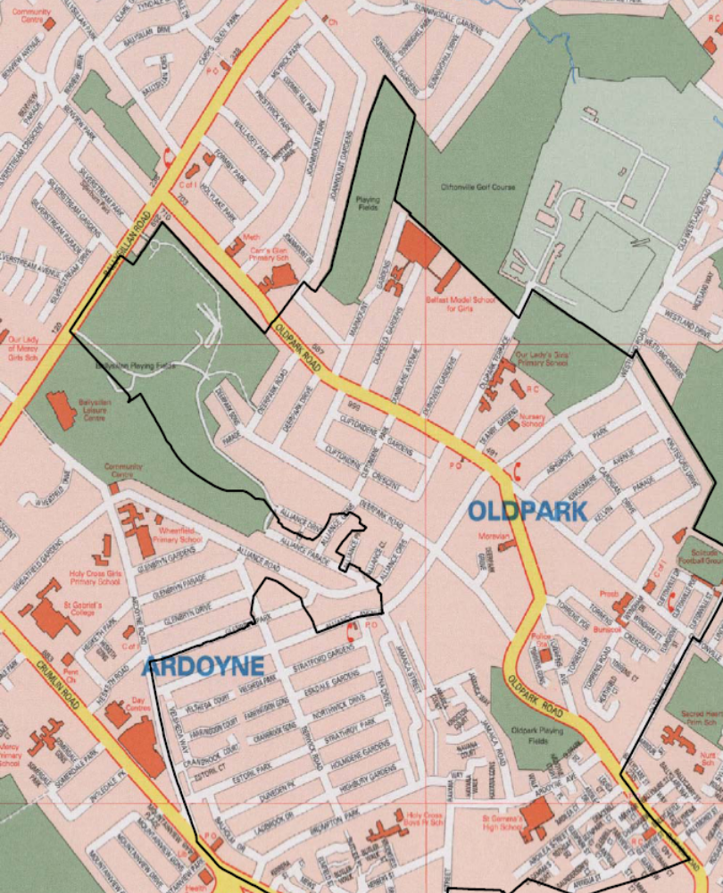
Off site Evacuation site,
Carrs Glen PS
Location of Belfast Model School for Girls
Off site Evacuation site,
Ballysillan Leisure Centre

School floor plans.

Ground floor positions of Fire extinguishers

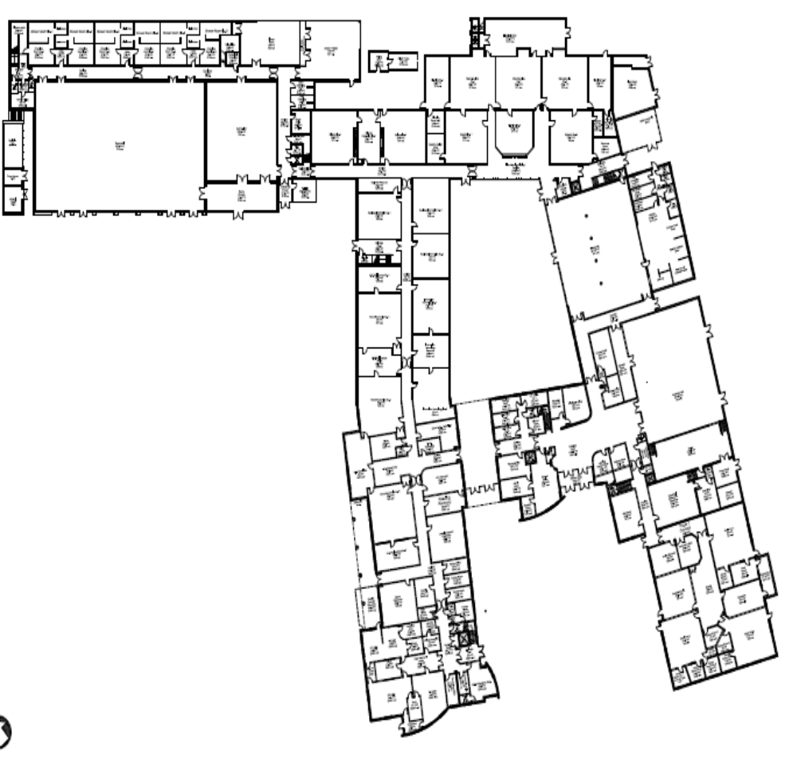
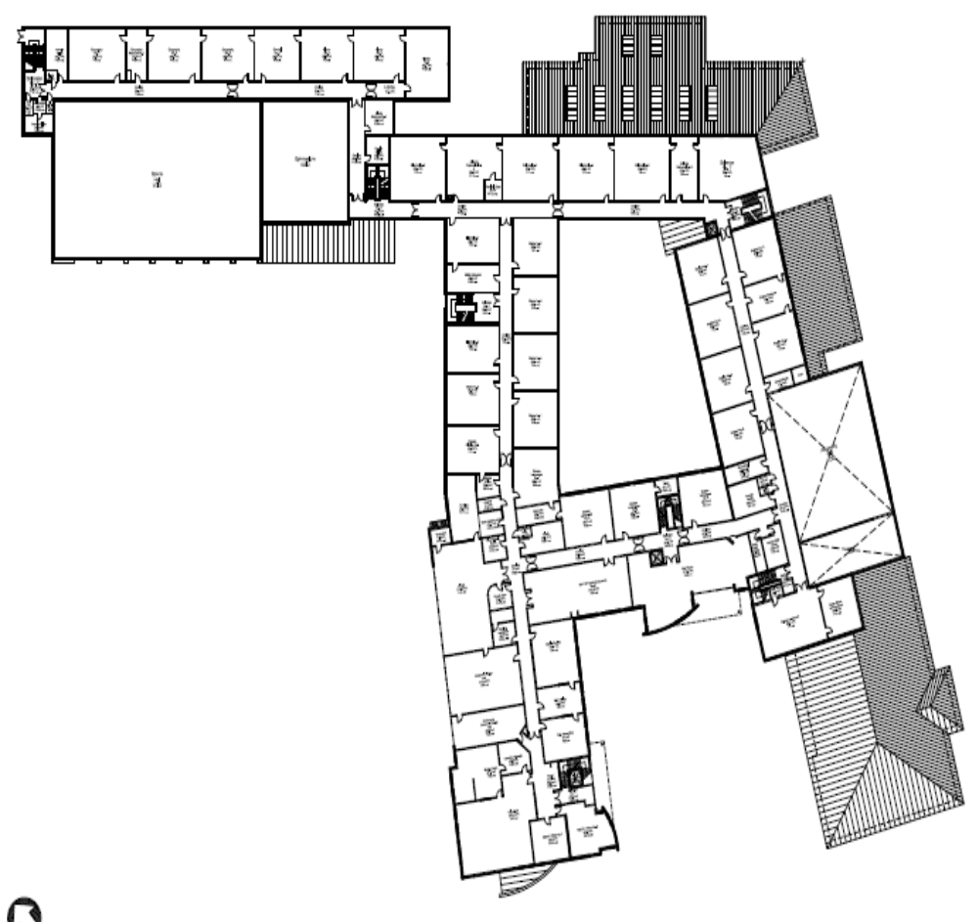

First floor positions of fire extinguishers
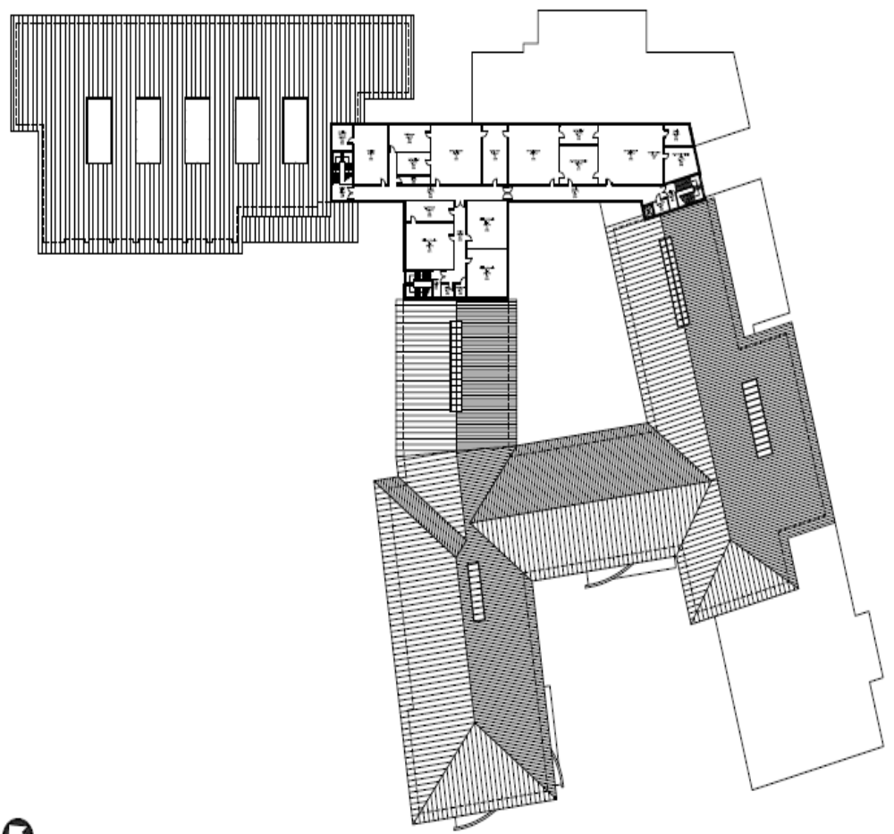

Second floor positions of fire extinguishers

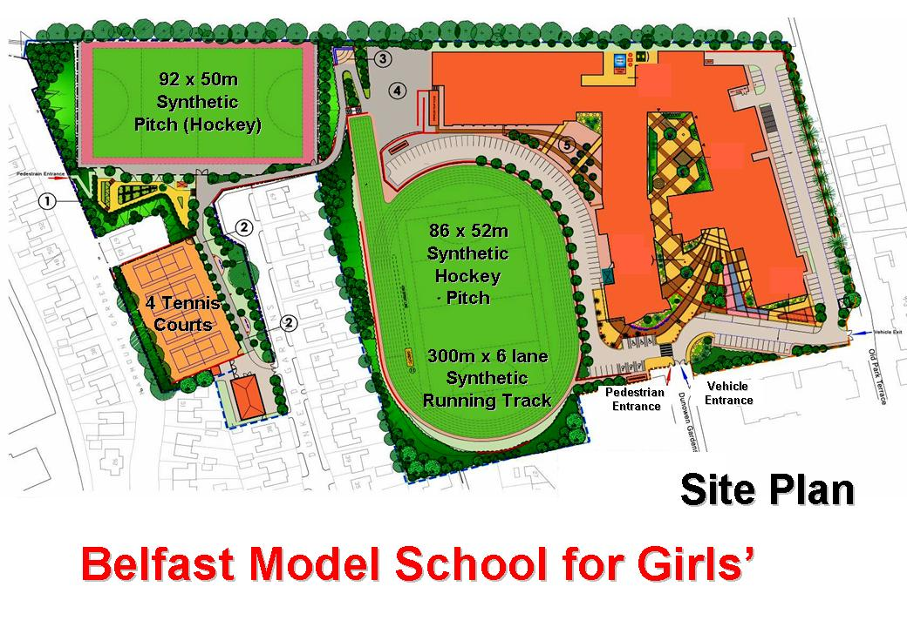
Muster point (evacuation routes outlined in black)

MUSTER POINT

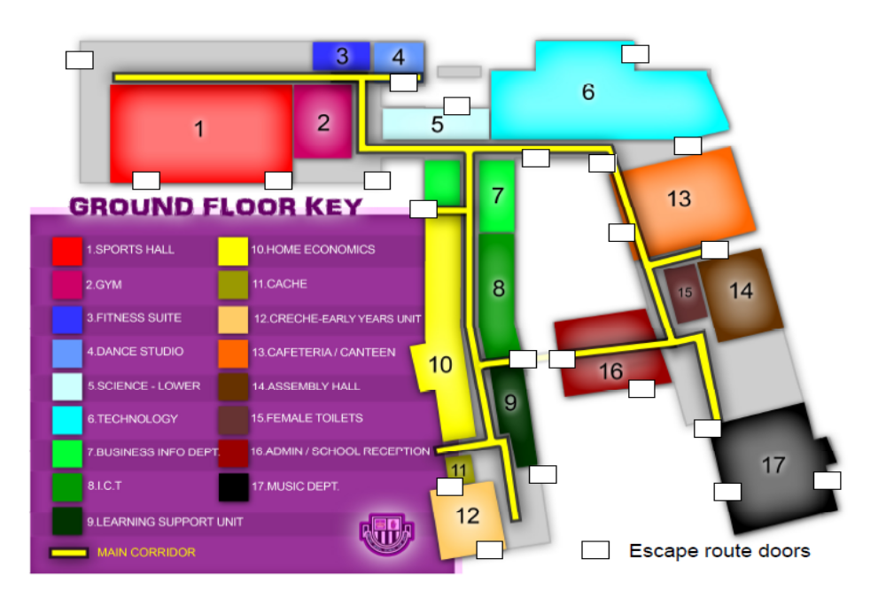
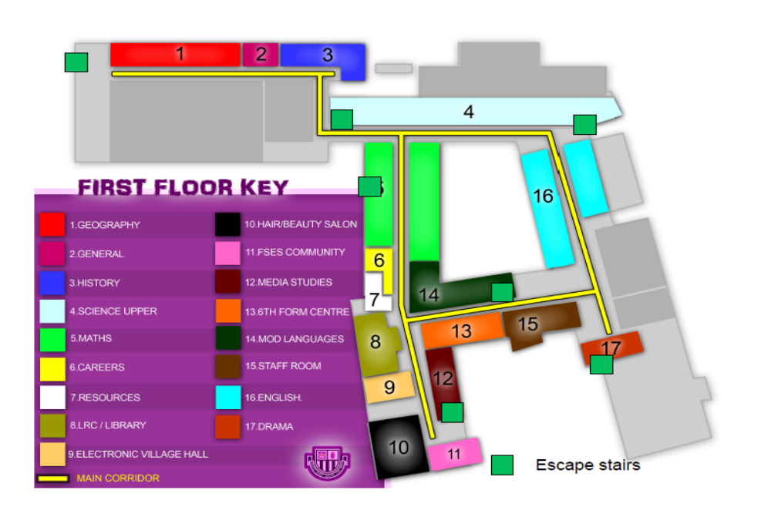

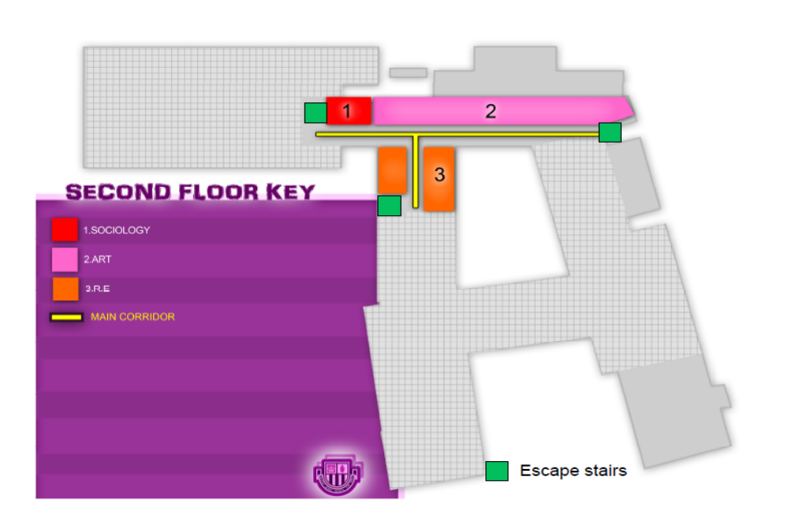

Appendix D

Emergency Response Procedures for Bomb Threats

Introduction

Although the board buildings may not be a major target for terrorists it may be a target for persons with a grievance against particular members of staff of the board/school in general. Terrorists sometimes plant bombs at random rather than targeting a specific business and the board/school might be affected because of where it is.

Terrorist attacks vary with the political climate, and media reports can help to assess the current level of terrorist activity. In addition advice may come directly from the Police.

A bomb can be easily disguised. It can be concealed in a car, van, lorry, briefcase, handbag, or carrier bag or it may have been placed in a biscuit tin, thermos flask and letter or posted packet. Incendiary type devices can be as small as a cigarette packet. Staff should always be encouraged to be alert to suspicious objects and person, both inside and outside the building.

It is important that the management team has contingency plans giving detailed procedures to be implemented in the event of an actual or threatened bomb attack.

Notification of a Bomb Threat

Notification of a possible explosive device on the premises may come via a number of avenues.

- Telephone or e-mail bomb threat.
- Suspicious letters or packages in the mail.
- Suspicious, unattended baggage or package discovered in an unusual location
- Direct Police advice.

Telephone Bomb Threat

If the switchboard receives a bomb threat, the person receiving the call must:

Keep calm and listen carefully.
Try to prolong the call as long as possible and to gain as much information as possible (questionnaire to be kept at hand).
Do not put on hold or try to transfer the caller.
Write down the message exactly asking the caller to repeat such information as:
- Did you place the bomb?
- Where is the bomb located?
- What kind of bomb is it?
- What time will it activate?

The person receiving the call must stay by the telephone until a member of the senior management team takes over the situation.

Suspicious Letters or Packages in the Mail

There are a number of signs that should alert staff to the possibility that a letter or package is an explosive device. These are:

- Grease marks on the envelope or wrapping.
- The envelope or package may smell of marzipan, almonds or petrol.
- The package may be unusually heavy for its size.
- It may be heavier in some places than others.
- It might be possible to see wires or foil especially if the package is damaged or there may be a strange noise, ticking, blipping and humming.
- Flickering LED light.
- There may be an excessive amount of wrapping or tape.
- The envelope may be wrongly addressed, poorly typed, poor handwriting or spelling.
- It may have a foreign or unfamiliar postmark.
- It may have been delivered by hand or be from an unknown source.

If members of staff are suspicious about a package, and there is an address on it, they should try to contact the sender. Enquiries should be made as to whether anyone is expecting a package.

If there is any reason to suspect that letter or package contains a bomb then the following steps should be taken.

- The package should be put down gently on a sturdy, flat surface.
- It should not be put into anything, including water and nothing should be place on top of it.
- The immediate area should be cleared.
- The senior management team should be contacted.

Suspicious Unattended Package

Staff should be encouraged to report anything which seems unusual or out of place. If a suspicious object is found the following steps should be taken.

- The object should not be moved.
- People should be cleared from the immediate area.
- Doors and windows should be left open.
- The senior management should be contacted.

Direct Police Advice

In the event of a suspicious vehicle or device being found or a threat of a terrorist attack is received, a decision has to be made by the senior management team in conjunction with the Police about the evacuation of the building.

Searching and Evacuating the Buildings

Upon receipt of a bomb threat the senior management team will decide whether to evacuate the building immediately or to search the property first and then move everybody out if something suspicious is found.

If a decision is taken to search the property first, the fire marshals/senior officers should be contacted by phone and asked to search the building. They should also undertake a search if the building is evacuated immediately. They should then report their findings to the senior manager in charge. The search team should be looking for an unidentified object:
- That should not be there.
- That cannot be accounted for.
- That is out of place.

Precedence should be given to searching main routes and public areas thoroughly; small bombs and incendiary devices can easily be hidden in furniture (down backs of seats) alongside rubbish bins, etc.

Police Policy on Search and Evacuation

The Police will not normally search buildings on receipt of a bomb threat for two reasons.

They are unlikely to know the layout of the building and the possible areas where a device may be concealed, whereas the occupants will.

They will not know what should, or should not be in a particular place.

If the bomb threat is deemed genuine, rather than a hoax, then the Police will assist with the possible use of dogs after a search has been completed.

Evacuation of the Building

Evacuation can to total or partial. There may be some cases when it is appropriate not to evacuate. In these instances staff should be informed to make their way to safer areas of the building away from the location of the bomb threat. Should a decision to evacuate the building be taken, then the following procedure, unlike a fire evacuation should be followed:

- Staff should be informed orally, (as normally evacuation routes may take them past the suspicious package), asked to collect belongings and clear the building. Evacuation should be to the most appropriate assembly points given the location of bomb scare. The removal of belongings will help the evacuation control officers in searching the building and save time. Staff must not use mobile telephone or radios.

- Windows and internal door should be left unlocked, and lights on.

- All persons leaving the building should be advised that the building would be closed when empty (they will not be able to re-enter the building) and they will be kept informed as to the duration of the closure.

- All main entrances and exits should be locked after the building is cleared.

Re-occupation of the Building

The senior management team with the assistance of the Police, after confirming that the building is safe; will decide when re-occupation will take place. This decision should be communicated to staff via the fire marshal/senior officers.

School Buildings – emergency response procedures for telephone bomb threats received by reception staff.

Action to be taken on receipt of a bomb threat

- Get a colleague to call a member of the senior management team.
- Keep calm and listen carefully.
- Record the exact wording of the threat.

____________________________________________________________________________________________________________________________________________________________________________________________________________________________________________________________________________________________________________
Ask these questions:
Where is the bomb located? __________________________________________________________________________
When is it going to explode? __________________________________________________________________________
What does it look like? __________________________________________________________________________
What kind of bomb is it, or is it an incendiary device? __________________________________________________________________________
What will cause it to explode? __________________________________________________________________________
Did you place the bomb? __________________________________________________________________________
Why was it placed? __________________________________________________________________________
Record time call completed __________________________________________________________________________

Keep the telephone line open.

Even though the caller has disengaged do not disconnect line or replace handset. Time informed
___________________________________________________________________________
Time and date of call ______________________________________________________________________
Length of call ______________________________________________________________________
Number at which call is received ______________________________________________________________________
Remarks
____________________________________________________________________________________________________________________________________________________________________________________________________________________________________________________________________________________________________________
Signature _______________________________________________________________________
Do Not Press the Fire Alarm

When the call has finished give this form to a member of the senior management team. They will decide whether to evacuate the building or to conduct a search. The more information that you can obtain the easier it will be to determine whether the warning was serious or not.

Notice for Staff and Visitors

The following instructions have been prepared as part of a complete response to possible bomb threats. In all cases the basic procedures are the same.

Remain calm.

If you discover a suspect item:

- Do not touch it.
- Do not immerse it in water.
- Contact your supervisor for fire marshal. Who must contact a member of the senior management team?
- Give details of the threat that you have received.
- Await further instructions.
- Do not set off the fire alarm.

If you receive a bomb threat by e-mail:

- Contact your supervisor. Who must contact a member of the senior management team.
- Give details of the threat that you have received.
- Await further instructions.

If you receive a telephone threat (direct line):

- Keep calm and listen carefully.
- Try to prolong the call as long as possible and to gain as much information as possible.
- Write down the message exactly. Ask the caller to repeat such information as:

  - Did you place the bomb?
  - Where is the bomb located?
  - What kind of bomb is it?
  - What time will it activate?

- Keep the telephone line open.
- Contact your supervisor. Who must contact a member of the senior management team.

If you are requested to evacuate the building:

- Do so in an orderly manner.
- Leave doors unlocked and windows open.
- If you are instructed, take your personal belongings with you.
- Do not use mobile phones or radios.
- Go to the designated assembly point, and follow given instructions
- Do not re-enter the building.
- Wait at the designated assembly point until you receive further instructions.
- For your safety – obey all instructions promptly.

Suspicious letters or packages in the mail – procedures for registry staff

There are a number of signs that should alert you to the possibility that a letter or package is an explosive device. These are:

- Grease marks on the envelope or wrapping.
- The envelope or package may smell of marzipan, almonds or petrol
- The package may be unusually heavy for its size.
- It may be heavier in some places than others.
- It might be possible to see wires or foil especially if the package is damaged or there may be a strange noise, ticking, blipping, and humming.
- Flickering LED light.
- There may be an excessive amount of wrapping or tape.
- The envelope may be wrongly addressed, poorly typed, poor handwriting or spelling.
- It may have a foreign or unfamiliarly postmark.
- It may have been delivered by hand or be from an unknown source.

If you are suspicious about a package and there is an address on it, you should try to contact the sender. Enquiries should also be made as to whether anyone is expecting a package.

If there is any reason to suspect that a letter or package contains a bomb then the following steps should be taken.

- The package should be put down gently on a sturdy, flat surface.

- It should not be put into anything, including water and nothing should be place on top of it.

- The immediate area should be cleared.

- The senior management team should be contacted.

Dealing with Media during Critical Incidents

Designation of Spokesperson/Media contact
As part of the critical incident planning, the school should nominate a spokesperson and a main contact for media queries. Should the media become involved, they should be directed to this contact for information. Rules regarding access to pupils, information dissemination by staff members should be clarified and articulated to all staff. Control of sensitive information is usually necessary and is more easily controlled if authority is assigned to one specific person.

This person must take the time to get the facts in order to speak with assurance to staff, parents and media.

Communication with Board
In an emergency situation head teachers can contact the board’s information officer as soon as possible for guidance about dealing with media.

The nature and seriousness of the incident will determine the media needs and support that the board should provide.

The board may advise the school not to speak to the media and direct all enquiries to the board’s information officer.

Drafting statement for Media
The statement has two functions: to meet the needs of journalists and also to counteract any rumours or other sources of information. Short statement to be emailed, faxed or read over phone.

Detail relevant information and facts: explain what happened, when, where, who was involved. Avoid speculating case or blame for incident.

Speak on behalf of school and governors and focus on positives or on a situation that could alleviate the conflict. Affirm main concern is the health and safety of pupils and staff and that the school is working closely with relevant authorities. Express school’s sympathies to families or victims if there are deaths or injuries.

Staff Communication
It is essential that all staff have the same information as quickly as possible so that teachers may respond to pupils’ anxieties and rumours. Even stating that no new information is available is news.

Release of Information to Parent/Community
Determination should be made of what parents need to know: the school is safe, kids are secure and action has been taken. Formats for the dissemination of this information may vary.

Inter-Agency Communications
Depending upon the nature of the critical event, a variety of helping agencies may become involved. Lines of communication may become confused, therefore, a contact person familiar with the on-site counselling services and community agencies can assist in avoiding confusion.

The task of coping with media pressures may fall to the police. In these circumstances events will happen at a very rapid rate.

The police press officer will need to liaise closely with school staff to ensure briefing is accurate and arrange interviews when appropriate. In the event of a major incident the police will take some actions immediately:

- Control access to the site to allow rescue services and investigators to carry out their work unhindered.

- Establish a media liaison point – this is a designated point at the disaster scene, preferably outside the outer cordon, for the reception of media personnel. It may be little more than a rendezvous point to start with, but can quickly grow into a media facility.

- Dispatch a media liaison officer – the swift attendance at the scene of a media contact (likely to be from the police) should ease the pressure from the media.

Press interviews
The media, particularly local broadcasters, can often be the best way of getting accurate information or advice to members of the local community. A brief interview with someone authoritative at the scene of an incident can be a powerful way of defusing rumour and panic which may otherwise spread quickly.

However, to people not used to being interviewed this can seem like very unwelcome pressure at a difficult time. Any member of the school community may be approached to give press interviews, including pupils. Journalists may want to get access to school premises or try to contact individuals at home.

Remember to include procedures on handling the media in the school’s emergency plan, and make sure all staff and governors are familiar with the guidance.

Points to note with media interviews:

- If possible, agree an interview format and establish what the interviewer wants to ask. Try to have another person with you to monitor the interview.
- Be clear in your own mind what you want to say, and talk it through with a colleague first if possible. But you will also need to be prepared to think on your feet.
- If possible, get statements checked by legal advisors and governors.
- Remember, you could be quoted on anything you say to a journalist, even if it is not a formal part of the interview.
- If you do not know the answer, say so.
- Stick to the facts and do not be drawn into speculation
- Don’t over-elaborate your answers.
- Do express your sympathies and don’t be afraid of showing a little emotion if appropriate. But try not to get angry, especially if it is for television.
- Don’t hypothesize or answer questions in a philosophical or “off the cuff” manner.
- Don’t try to be funny or witty. Keep answers short and to the point.
- Do not underestimate the media interest and stress or difficulty in dealing with the media. Any attempt to keep the news secret will allow rumours to flourish and will encourage the media to push harder for information.

Remember you can:

- Refuse requests for photographs or schoolwork of children or staff involved.
- Ban journalists form wandering around school premises.

Communication with Media Checklist:

Designated media contact ___________________________________________

Designated spokes person ___________________________________________

Identify area for receiving telephone calls _____________________________________

Contact/spokesperson clearly identified to staff ___________________________________

Contact BELB information officer _____________________________________________

Staff clearly directed NOT to talk to the media ___________________________________

School secretaries briefed immediately
“Call I have your name, the name of your newspaper, radio
TV station and your number. Someone will get back to you.” ________________________

Preparation of written statement _______________________________________________

Reading of written statement is only information given _____________________________

Delay the release of names until it is possible to release them; i.e. family members have been notified; next of kin have been notified by police ___________________________________

Set up regular times for a press release or press conference ___________________________

Establish control of press/video release. Location should be where you are comfortable, i.e. your own office.

Fire prevention – good practice

TYPICAL FIRE HAZARDS

- Flammable liquids (particularly in laboratories)
- Electrical equipment
- Cooking facilities
- Accumulation of combustible materials
- Heat Sources – ovens, boilers and heaters
- Cigarettes and other smoking material
- Arson attacks
- Hot work i.e. welding (both gas and electric)
- Liquefied Petroleum Gas for heating and cooking

REVIEW OF EXISTING FIRE PRECAUTIONS

- Fire precautions should be reviewed, in particular practical areas that have a higher fire risk such as workshops, laboratories, kitchens, stores
- Ensure that the means of escape from buildings are unobstructed and readily available
- Ensure that the fire alarm and emergency lighting system are operational
- Carry out a fire drill
- Fire fighting equipment should be available throughout the school.

PREVENTATIVE MEASURES

- Combustible materials should be stored in a secure area, and should be removed from the building as soon as practical
- Generally, electrical equipment should be disconnected at the end of the day
- Only systems that are absolutely necessary should be left on e.g. boilers, security systems, servers etc.
- All LPG gas systems should be isolated within the building. Heating systems are exempt
- In practical areas such as laboratories and workshops, work using flammable liquids or flames should be kept to a minimum during the strike period
- Strict adherence to the Smoking Policy. In areas where smoking is permitted all material should be extinguished and disposed of
- At the end of the day the Amey/FM manager should thoroughly check the building prior to securing the premises (all fire doors shut, if applicable, fire systems fully alarmed)
- Arson may increase during the strikes. In order to prevent this occurring ensure that all combustible materials, bins and skips are kept secure. Arrange from frequent removal
- Encourage neighbours where possible to be vigilant and report anything suspicious.

PERSONAL SECURITY
GENERAL ADVICE FOR TEACHING AND ANCILLARY STAFF

Recent threats have been made public in the media concerning teaching and ancillary staff working in schools. The following general advice is given in relation to personal security for those persons who feel they may be at risk.

- Always be aware of what is going on around you, no matter where you are.

- If possible avoid setting patterns in your travel arrangements, which could make it easy to predict you whereabouts.

- Change your routes and times of departure regularly.

- Travelling in company is better than travelling alone.

- Note any suspicious or strange persons or vehicles, and report same to the police.

- If you think you are being flowed drive, or if on foot make your way to the nearest area where there are plenty of people.

- Keep the doors of your vehicle locked when travelling through areas where you feel vulnerable.

- When walking try to avoid short cuts through deserted or dimly lit areas.

- Be cautious with strangers; do not give away personal information unnecessarily.

- Do not publicise your movements. Restrict the details to a few trusted people.

- If alone in a building ensure that all exterior doors are locked and there is plenty of lighting. Before leaving the security of the building check the area outside for any suspicious persons or vehicles. If you see anything that threatens your security remain in the building and inform the police.

- Avoid confrontation, if you are threatened leave the area as soon as possible.

- Fear is a natural emotion. Avoiding violence is a sign of strength not weakness.

- Discuss any concerns that you may have with regard to your safety with the school Principal.

Suspicious packages – Anthrax

GUIDANCE ON DEALING WITH SUSPICIOUS MAIL AND PACKAGES

General

- Examine (feel) unopened envelopes for foreign bodies or powder.

- Do not open letters with your hands – use a letter opener.

- Open letters and packages with a minimum of movement to avoid spilling any contents.

What type of letters and packages may be suspect?

- Any letters or packages that has suspicious or threatening message written on it.

- Letters with oily stains.

- Envelopes that are lopsided, rigid, bulky, discoloured, with an unusual amount of tape on them or have a strange odour.

- Unexpected envelopes form foreign countries.

- No postage or non-cancelled postage.

- Improper spelling of common names, places or titles.

- If it has any powdery substance on the outside.

What do I do if I receive a suspicious letter or package?

- Do not open the envelope or package.

- Leave it and evacuate the room, if that is practical and keep others from entering.

- If possible place the envelope or package in a plastic bag and place that inside another plastic bag and seal.

- Notify your line manager, who should immediately call the Emergency Services 999 who will advise on further management.

- List all the people who were in the room or area where the suspicious package was discovered and provide this to the Emergency Services and Public Health Authorities for follow-up investigations and advice.

What if I open a letter or package which contains suspicious material?

DO NOT PANIC

- The most common form on anthrax affects the skin. The two other types of anthrax infection affect the intestines and respiratory system. To become infected the organism must be rubbed into damaged skin, swallowed or inhaled as a fine, aerosolized mist. All forms of the disease are generally treatable with antibiotics.

- Anthrax cannot be easily aerosolized out of an envelope or package containing powder. The same applies to other bacteria likely to be considered as biological weapons.

CONTAIN THE EXPOSURE

- Close off the room (doors and windows), do not allow anyone other than Emergency Personnel to enter.

- If possible and without further risk of exposure to yourself, close the envelope or package to limit additional exposure.

- Do not attempt to clean the powder up and keep others away.

- Do not touch your eyes, nose, hair, or any other part of your body.

- If possible, wash your hands thoroughly with soap and water.

- If clothing is heavily contaminated, do not brush vigorously.

- If possible arrange for the buildings heating/air conditioning/ ventilation systems to be closed down.

- Make a list of people who had actual contact with the powder for Emergency Services and Public Health Authorities.

- The Emergency Services will take control of the situation once they have arrived on site.

What if I open a letter or package which contains suspicious material at HOME?

CONTAIN THE EXPOSURE

- Follow the directions as above and contact the emergency services.

Appendix E

Flowcharts and diagrams
Emergency accommodation centre
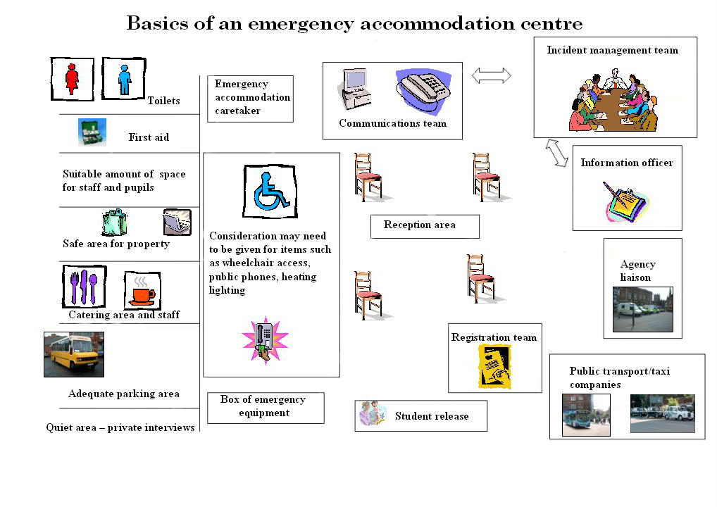

Immediate emergency response actions examples

Incident outside school | Bomb Threat, et | Immediate threat to school | Unsafe to remain in the building | Unsafe to remain on school grounds
Shelter –in-place | Short-term shelter in place | Lockdown | Evacuation | Off-site evacuation
Normal School day, outside activity curtailed, no authorised personnel | School population moved to a single location within school | Staff and pupils secured in the rooms that they are occupying | Staff and pupils evacuate building and assemble at assigned area | Staff and pupils evacuate school grounds and assemble at designated safe location
Principal announces implementation | Principal announces implementation | Principal announces implementation | Principal announces implementation | Principal announces implementation
If outside, pupils proceed to their classrooms | Staff and pupils proceed to designated location | Staff will secure doors, over windows, etc. | Fire alarm sounded | Principal determines safest method for evacuation
Classes to continue as normal | Teachers check class registers | Teachers, pupils remain in room until further instructions received | Teachers and pupils evacuate building to assembly area | Teachers will take attendance once assembled in a safe location
Amey/fm managers/assigned staff lock exterior entrances | Principal assists emergency services | If outside, pupils will return to classrooms | Teachers take attendance at assembly area | Teachers and pupils will stay in place until further instructions given
Assigned staff monitor main entrance | If long term shelter required, Principal will consult the board | Front entrance locked, Only emergency personnel allowed on grounds | Teachers and pupils remain in place until further instructions given | Principal may authorise return to classrooms if clearance given by appropriate agencies.
All clear given | All clear | All clear | All clear

